To: All Residents
SW9 Community Housing

09 June 2026

Dear Resident,
SW9 Housing Office & Reception Closure
I am writing to advise you that from 9.00am, Monday 15 June, the SW9 Reception will be closed for essential maintenance works, resulting in us unable to see residents in person.
During this time, you will still be able to contact us by:
Telephone on 0207 326 3700, Monday, Wednesday to Friday, 9.00am to 5.00pm, Tuesday, 10.00am to 5.00pm
Email: info@sw9.org.uk
We anticipate for the office to re-open on Monday 29 June, from 9.00am.
We apologise for any inconvenience this may cause.
If you have any questions, please do not hesitate to contact us.
Yours faithfully,
Kellie Carson
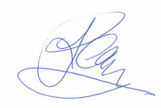
Head of Customer Service

