To The Residents Of SW9

26 February 2026

Dear Resident,
Meet Your SW9 Board & The Senior Leadership Team
I would like to invite you to the first Resident Meetings of 2026, taking place on:
Tuesday 10 March 2026
6.30pm to 8.00pm
Community Trust Centre 21 Aytoun Place, SW9 0TE

Members of the SW9 Board will be in attendance alongside our Senior Leadership Team and a representative from our parent organisation, Sovereign Network Group.
My team and I will be provide feedback from previous meetings, and present our operational plans for the coming season. The meeting will give us a chance to hear directly from you about our services.
I look forward to meeting you there.
Yours faithfully,
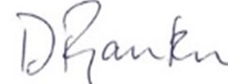
Delroy Rankin
Executive Director

