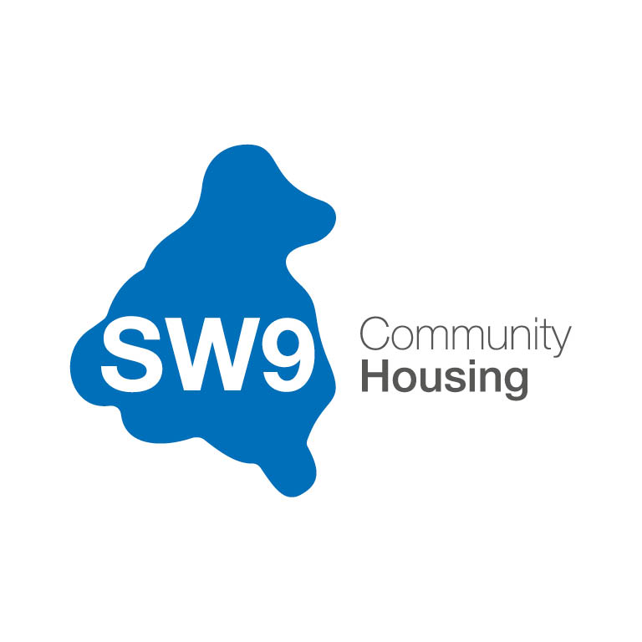

BOARD MEMBER

RECRUITMENT PACK

2025

CONTENTS

Welcome letter from the Executive Director 03
About SW9 04
The Stockwell Story 06
Becoming a Board Member – Frequently Asked Questions 10
SW9 Community Housing Board 2025 14
SW9 Organisation Chart 16
Board Member Role Description 19
Board Member Person Specification 21
Selection Process and Key Dates 25
Application Form 27
Supplementary Documents 32

WELCOME LETTER FROM THE EXECUTIVE DIRECTOR

Dear Applicant,
Thank you for showing an interest in one of the vacant SW9 Community Housing Board Member positions. In this Board Member Recruitment Pack, you will find everything you need to know about the organisation, our Board, what we are looking for in a Board member and the application process.
To submit your application, or if you would like to discuss the role and whether it is right for you, please contact:
Telephone: 020 7326 3700
Email: board@sw9.org.uk

The closing date for receipt of applications Friday 09 January 2026, 17:00hrs.

Yours faithfully,

Delroy Rankin
Executive Director

ABOUT SW9 COMMUNITY HOUSING
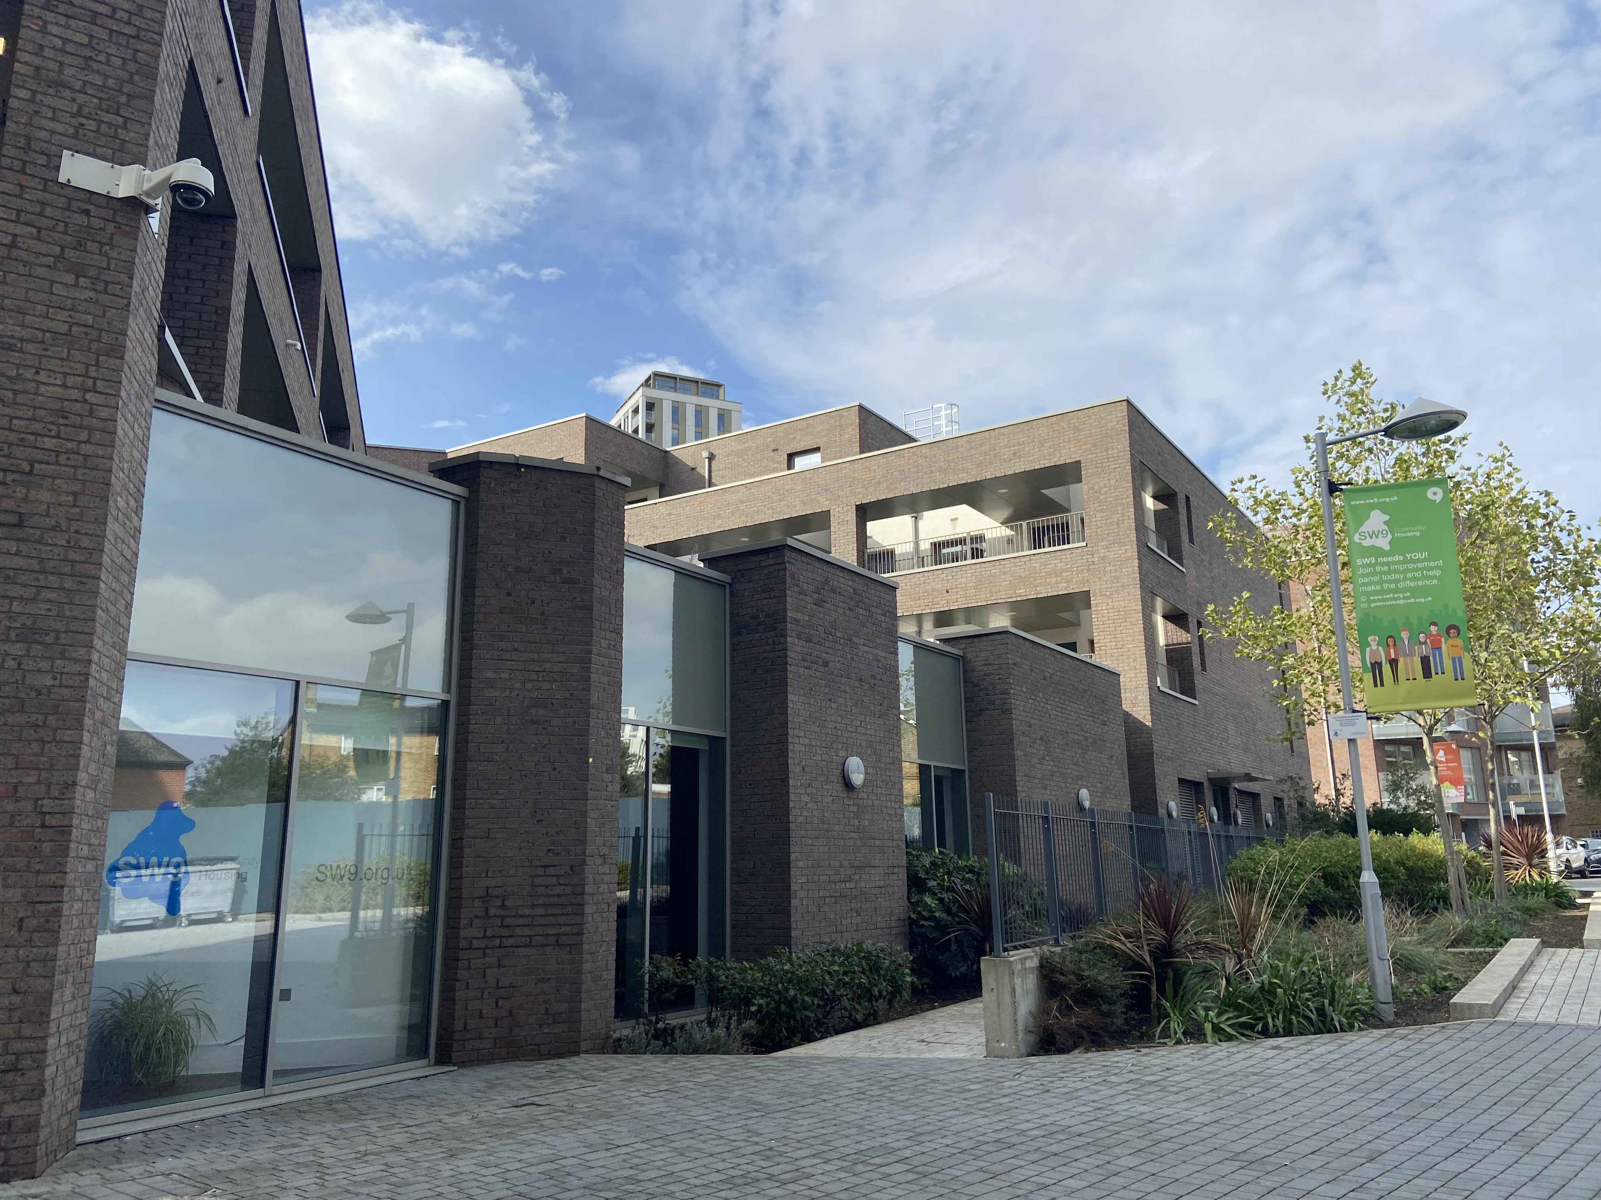

SW9 Community Housing was created in 2016 to work closely with Stockwell’s residents and to build a bright future for the estate. As the housing management organisation for Stockwell Park Estate and surrounding street properties, we manage the day-to-day housing services for 1,749 homes on behalf of the landlord - our parent company, Sovereign Network Group (SNG).
Our mission is to:
“Work in partnership with local people to provide effective and sustainable housing services, enabling our community to flourish.”

Our values
Our values reflect our commitment to providing excellent services and community cohesion through the empowerment of our residents:
Independence – SW9 aims to operate as an independent socially responsible business that builds on the accomplishments of both CTH and SNG.
Local – SW9 wishes to retain its close local links and support local people and businesses.
Quality – SW9 wishes to provide good quality housing and services which will not only benefit residents but also enhance their quality of life. We will also demonstrate, deliver, and promote recognised good practice within the tenant-led housing sector.
Working in partnership – SW9 is keen to work in partnership with the local authority, other housing providers and organisations whenever this will benefit the provision of local housing and services.
Value for money – SW9 aims to ensure it delivers competitive, high-quality services that represent value for money for our residents.
Financially sound – SW9 will be prudent in its financial management. This will ensure a strong and viable future with the ability to continue to maintain existing homes and offer a full range of services to a high standard.
Integrity – The Board and staff will operate in an environment which supports the highest levels of integrity: where openness is encouraged across all our activities and with our stakeholders and partners. Our governance will be regularly reviewed to ensure appropriate controls and accountability across all areas of our business.

SW9 Community Housing in numbers
The total number of properties we manage is 1,749. This is made up of:
913  General Needs | 660  Leasehold | 60  Shared Ownership
48  Supported Housing | 40  Active Elderly | 28  Short Term Lets

THE STOCKWELL STORY
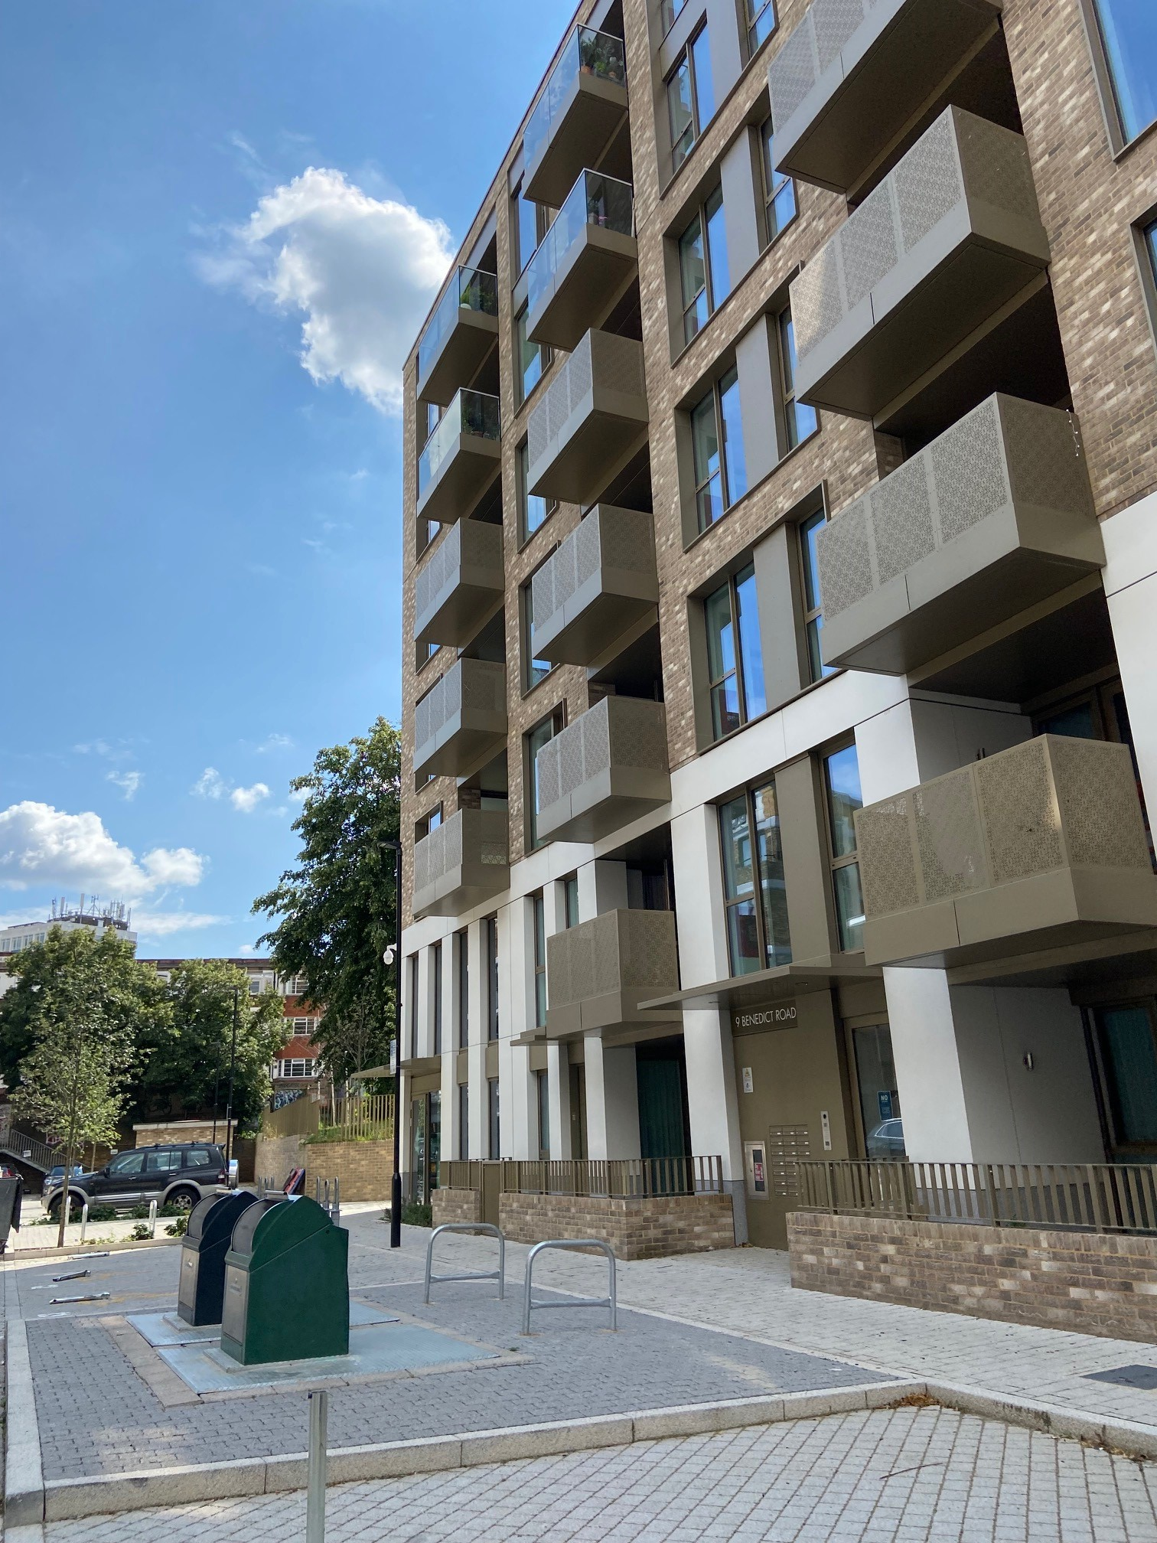
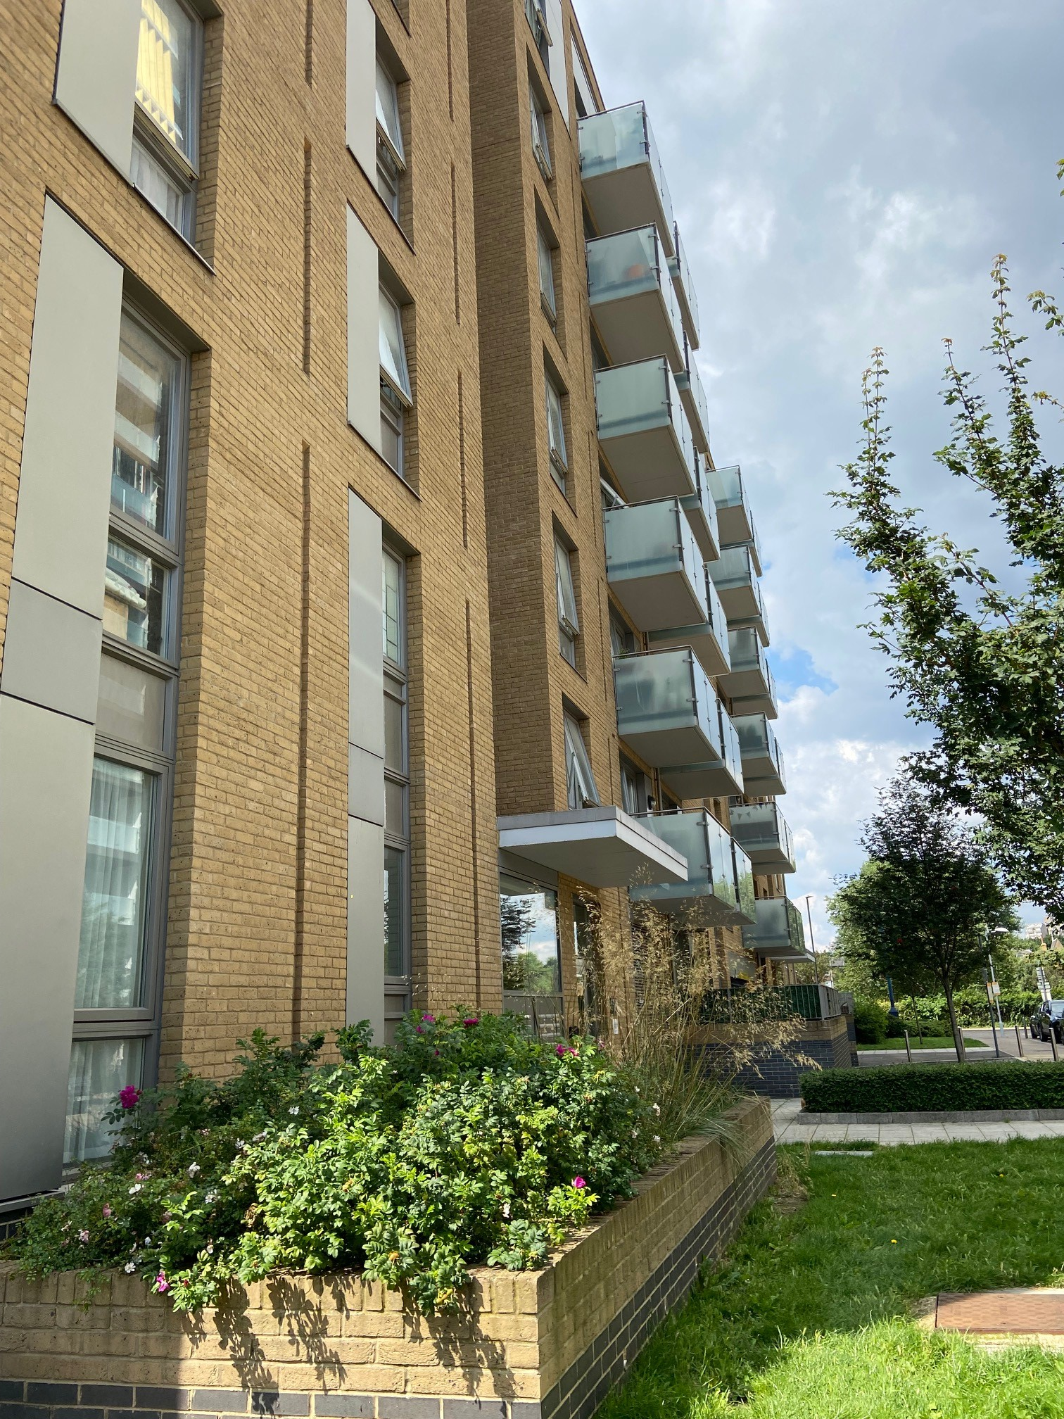

Homes and the people who live in them are important to us. They’re the reason we do what we do.
There’s a strong sense of community and a tradition of community engagement in the way that housing on the Stockwell Park Estate is managed. We believe it is this tradition and heritage that makes the area so special. This sense of community has grown over a story stretching back more than 25 years.
Although Stockwell Park had originally been created as an example for modern living and vibrant communities (winning several awards for its multi-level design in the 1960s), some thirty years later it was considered a failing estate. Ranked as one of the worst places for crime, anti-social behaviour (ASB) and deprivation both within London and nationally, it had also become closely associated with the Brixton Riots of the 1980s.
With some irony perhaps, many of the problems identified were seen to be a direct result of the design which had been applauded during the 1960s. The multi-level access design feature had led to ASB moving from the streets to the podium level where it was difficult to police. As a result, many services were unwilling to fully engage in the area, including the postal service.
In 1995, a group of residents led by Julie Fawcett, lobbied Lambeth Council for action to be taken for the Estate. They formed the Stockwell Park Community Trust – a Tenant Management Organisation (TMO) – allowing them to take advantage of the Estate Action Funding programme. This would see the bill for much-needed investment shared equally between the local authority and central government.
A year later, the regeneration of the estate kicked off in earnest with Fitzgerald House being the first to undergo refurbishment. This largely centred on moving front door access to ground level, to create a greater ‘overlooking’ of the estate. Between 1997 and 2001, improvements carried on apace with large scale refurbishments at Burrow House, Turberville House, Crowhurst House, Chute House and the Community Centre. However, with only the inner core of the estate completed, Estate Action Funding was brought to an end meaning work would have to cease unless alternative funding could be found.
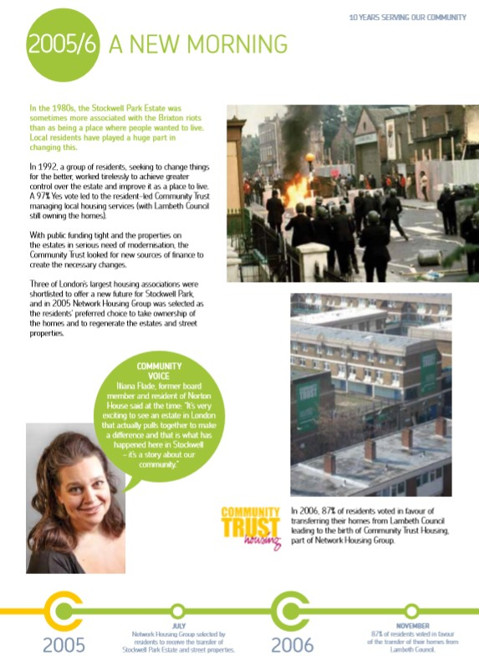
The Stockwell Park Community Trust now looked to the increasingly popular stock transfer model (which was being used around the country) to unlock this potential. Between 2002-3 a stock option proposal was created including a feasibility study. The advice from this was to become more adventurous; to also create new homes as well as refurbish the existing stock (which was simultaneously being brought up to the government’s 2010 Decent Homes Standard through bids to central government).

Although a range of partners were explored, including many of London’s G15 Housing Associations, the Trust wanted to maintain as much independence as possible rather than become amalgamated into a wider group. The decision was therefore made to partner with Network Housing Group, now Sovereign Network Group (SNG), which operated on a more federal structure incorporating a variety of different housing providers each with their own Board and aspirations.
In 2005 a ballot of residents was held with a staggering 79.9% voting in favour of transfer. This was largely down to the hard work of the TMO staff and volunteers who took pride in their mission, door knocking and holding events to promote the potential good the partnership could do for the local area and residents.
On 31 March 2007, the newly renamed Community Trust Housing (CTH) began operating as a part of the Network Housing Group, with Denchworth House being the first beneficiary of regeneration. The new relationship continued to thrive despite the impact of the wider national environment, including the financial crash of 2008.
Promises were kept by switching a number of properties intended for outright sale to general rent, leading to greater than planned mixed communities when Lidcote and Cumnor were completed.
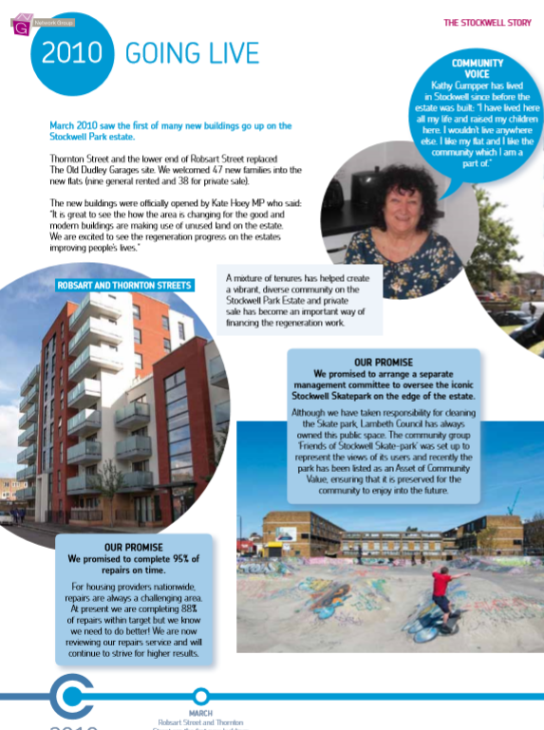
This period also saw the completion of the first new build properties with 57 homes developed on the site of the old Dudley Garages, now renamed 19 Robsart Street. The successful completion of these projects was a matter of great pride, as they were managed internally with no support available from Lambeth Council in the necessary decant work. This success directly led to the decision to demolish Weyland House (which had been due simply for refurbishment) so that the award-winning Park Heights could be constructed.

Again, times were changing and, when a change of focus at Network Housing Group led to plans to collapse the group structure, CTH worked to maintain its independent nature. A two-year negotiation led to an arrangement whereby Network Housing Group could become one organisation, but CTH could also remain in a manner that respected its local character.
With a Management Agreement in place, SW9 Community Housing began operation in March 2016. A new organisation with its own resident-led Board and purpose-built offices, the arrangement allowed SW9 to retain 53% of rental agreement over a period of 25 years with an option to seek independence after 5 years.
As the housing management organisation for the Stockwell Park Estate and surrounding street properties, SW9 Community Housing works closely with its residents to build a bright future for the estate while managing the day-to-day housing services for 1,749 homes on behalf of the landlord – its parent company, SNG. It is part of a tradition that we are proud to continue.
The current decision which affects the Stockwell Park Estate and surrounding street properties is just as important (if not more) than some of the momentous events navigated by previous board members in predecessor organisations. It is to decide whether the future ownership of the Estate should remain in the hands of the ‘corporate entity’ that is SNG, or whether present and future residents of the Estate would be better served by having ownership more closely aligned with the management and services provided to the Estate and its residents, by a locally focussed organisation that is SW9. This is a complicated and complex decision for which a ballot of residents is necessary.
In representing the arguments ‘for’ and ‘against’ independence, many residents will have due regard for the Estate’s history and the progress made thus far. But in reality, how much should historic events of the past influence plans for the future, indeed, should they have any bearing at all? These are the type of questions which will need careful consideration now, to arrive at clear strategic answers to some of the questions which will inevitably be posed by residents.
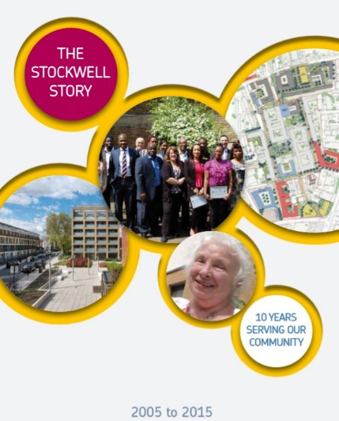
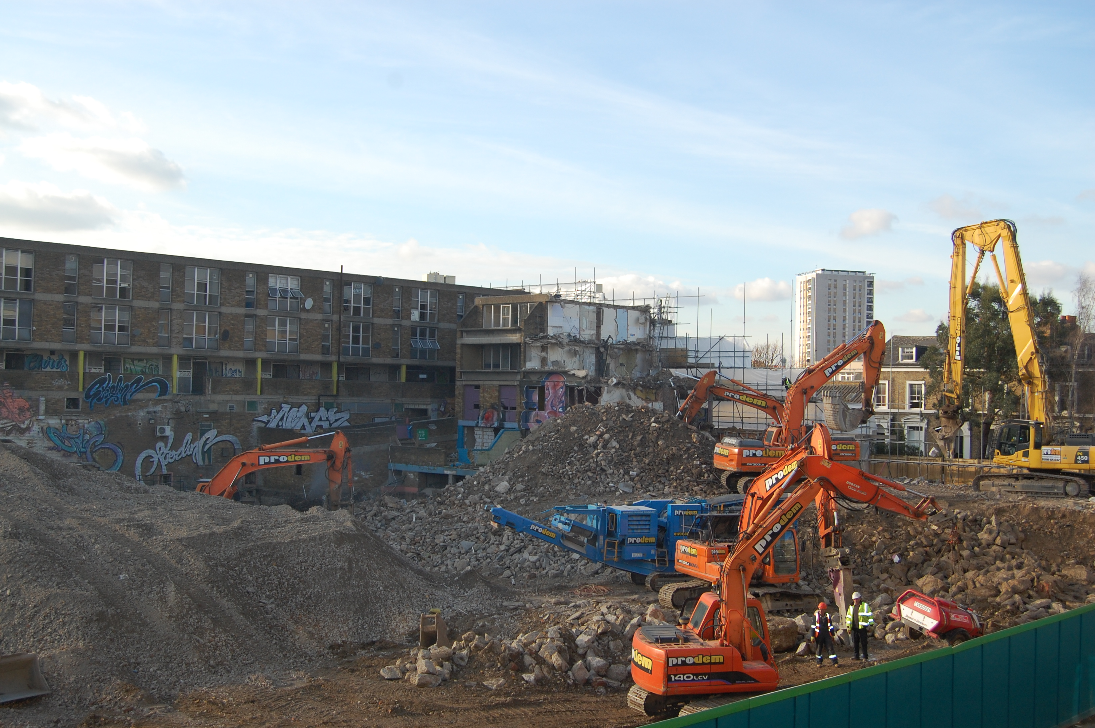
This document has been adapted from ‘The Stockwell Story’ originally published by Community trust Housing in 2015.
If you would like a copy of the original, please contact communications@sw9.org.uk

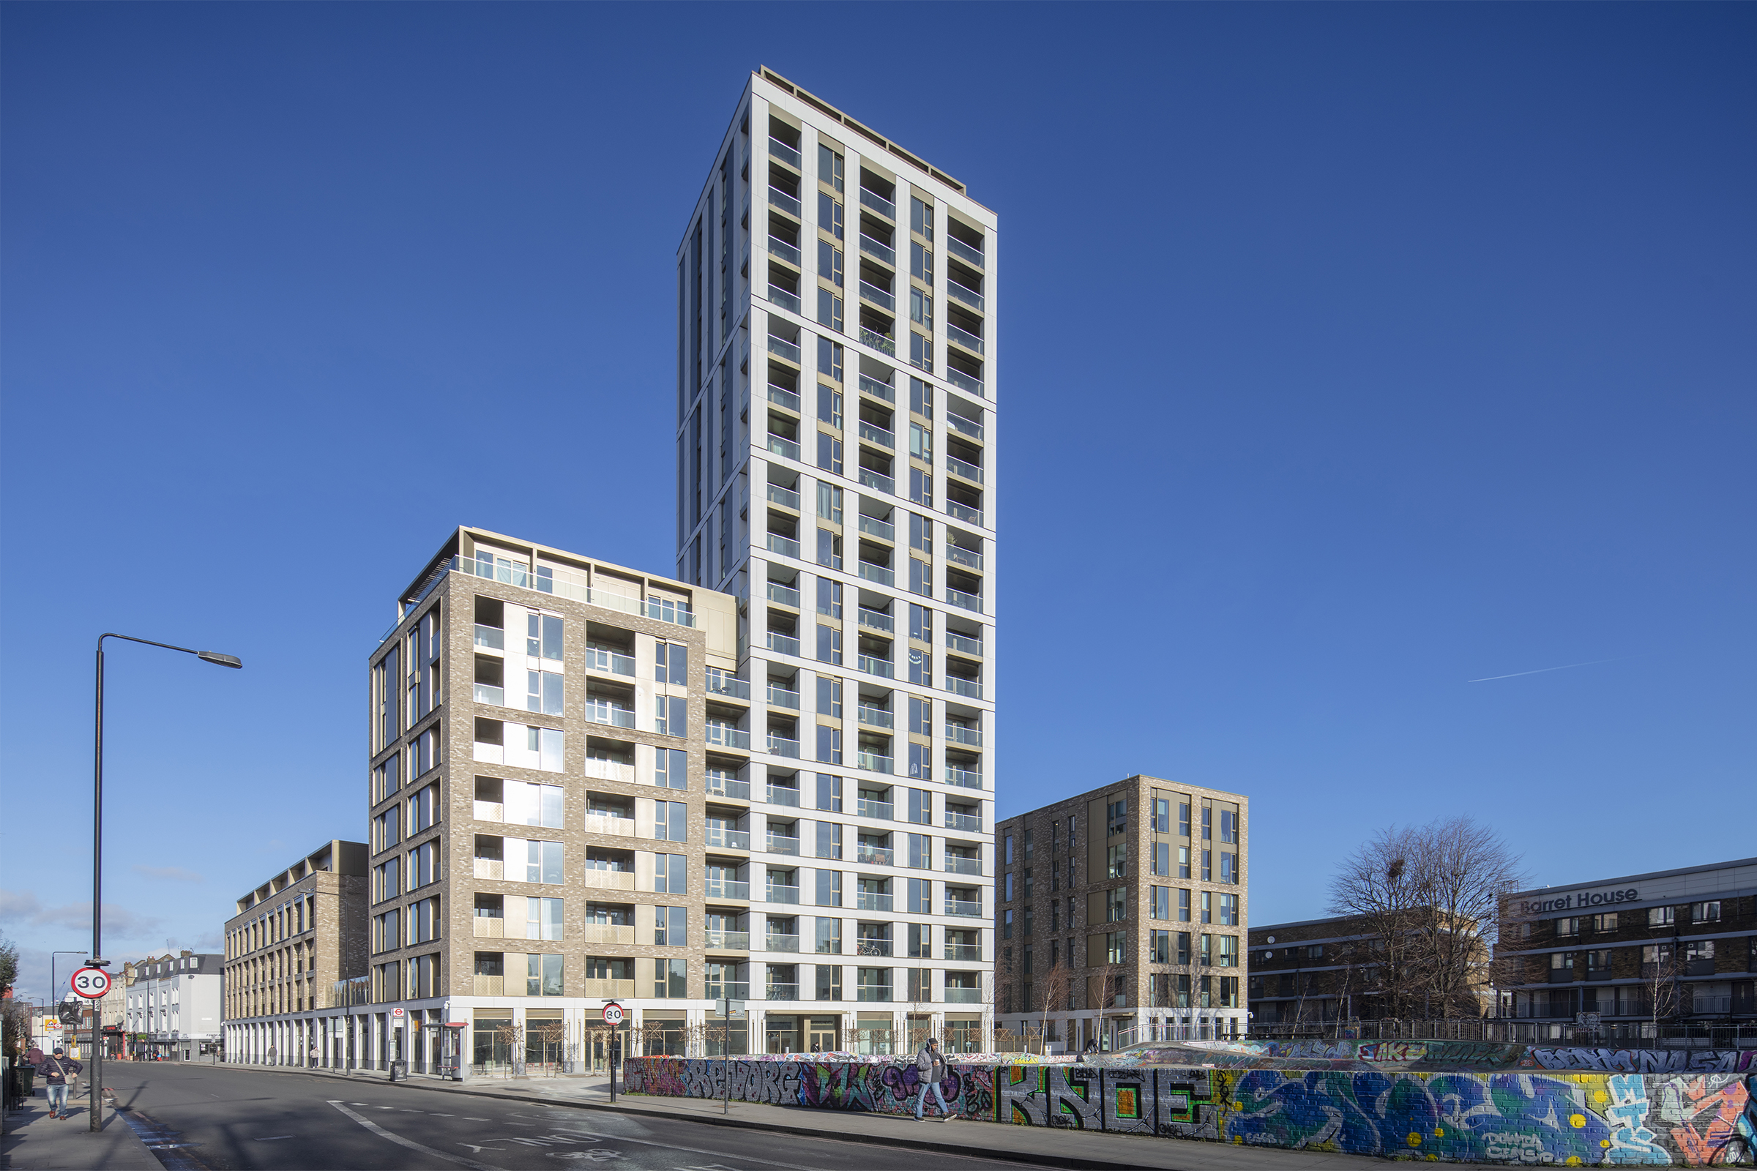

BECOMING A BOARD MEMBER – FREQUENTLY ASKED QUESTIONS

- What is a Board? What does it do?

A Board is a group of elected or appointed individuals who jointly oversee the activities of a company or organisation.

The SW9 Community Housing Board will set our strategic direction and is accountable to our residents and other stakeholders for our overall performance in delivering housing services to our residents.

If you are on the SW9 Community Housing Board, you will also have responsibility for:

- The overall management of the organisation.
- The approval of the corporate plan.
- The approval of our annual report and financial statement (this is also subject to external audit).
- Deciding which areas of responsibility are to be delegated to committees or our staff.

However, the day to day running of the organisation is delegated to our Senior Leadership Team.

- How are SW9 Community Housing Board members chosen?

If you’re interested in becoming an SW9 Community Housing Board member, then you’ll go through a recruitment and selection process. This is to make sure you know what is involved while also giving us an opportunity to check that you’ve got the right skills and are able to put in the necessary time and commitment.
First you will need to complete an application form. This will give you the chance to tell us about yourself, your skills, knowledge, and experience. We will then review the applications we receive and draw up a shortlist. If you are on the shortlist, we will ask you to come and see us for an interview.

If we have more suitable applicants than vacancies to become SW9 Community Housing Board members, the process may then move on to a second stage, which could include an election.

Please note, as part of the process, SW9 will check your account to ensure you are not in any arrears. If your account in arrears (rent, ground rent or service charges), we may not be able to continue with your application. In the event this scenario takes place, we will endeavour to have an open and transparent conversation with you.
- What if I’m not chosen to become an SW9 Community Housing Board member? Will I have wasted my time?

Absolutely not! If you don’t manage to become an SW9 Community Housing Board member on this occasion, then you will get another chance to try again next time.

In the meantime, Komal Doan, Customer Resolutions Manager, can talk to you about other opportunities that may be of interest and will certainly help you gain more knowledge for the next time you put in an application.

- How much time will I have to commit to being an SW9 Community Housing Board member?

It is difficult to be exact as the time involved will depend on what needs to be discussed. As a general guide there are likely to be:

- Six x 2-hour meetings per year (usually on the last Tuesday evening of each month).
- About three hour’s preparation at your own time before each meeting to read notes and reports.
- Personalised training programmes.
- A few occasions where you represent the organisation at external meetings or open events.
- Attendance at one or two “away days” per year.

In addition, you may be required to sit on two committees which meet approximately four times a year. The extra time commitment for this varies by committee and will be discussed with you beforehand.

- What would make a great SW9 Community Housing Board member?

We are looking for certain key values in an SW9 Community Housing Board member. We want them to help us achieve homes and neighbourhoods we can all be proud of and support the values that underpin our daily activities. We expect them to further the wellbeing of our organisation, residents, and the wider community in which we operate. We also need them to execute their role responsibly and ensure confidentiality is maintained.

We want SW9 Community Housing Board members to make decisions that allow us to make a difference.

- What skills do SW9 Community Housing Board members need?

The following would make a great start:

- Team working – you must be able to work positively as a member of a diverse team. You will face sensitive / challenging issues and will need to accept differing views, being ready to compromise if required.
- Self-management – you need to be enthusiastic and committed to all your responsibilities.
- Decision making – you must have the ability to weigh up issues and make balanced and reasonable judgements and decisions.
- Analysis and challenging – you need to have the skills to analyse, question and constructively challenge issues.
- Communication – you will be an effective communicator with tenants, leaseholders, our staff, and other members.
- Bigger picture – you need to be able to put aside your personal feelings and be able to think strategically for the wider SW9 community.

- What would I get out of being an SW9 Community Housing Board member?

Being an SW9 Community Housing Board member would mean making a difference in the area you live. You will be enhancing the lives of your neighbours by taking decisions that will improve homes, communities, and individual lives.

Here’s an idea of what you’ll get back by becoming an SW9 Community Housing Board member:

- Gain experience – being part of the SW9 Community Housing Board will give you some really useful experience and skills that are easily transferable to other situations. Our current and past members tell us that the skills and knowledge they built up have helped their personal development and were a very useful addition to their CVs.
- Getting you thinking – our members have to make some difficult decisions. You will be analysing, reviewing, and debating on a regular basis. This might sound overwhelming, but with our support through training, you’ll be ready to take on even the biggest challenge.
- Acquiring skills – we know that for some, becoming a Board member can be a new experience. So, for all our new members we run an induction session and then, according to your particular needs, we put together an annual training programme so that you’re fully prepared.
- Being effective – You will make a lot of important decisions that will positively impact on the lives of residents and shape the neighbourhood in which they live.
- Achieving change – there’s often a great sense of satisfaction and fulfilment in the knowledge that you will be achieving positive change by being part of an effective and responsible Board.
- Covering costs – although being a member is a voluntary role, we will cover any relevant out of pocket expenses. That might include training or transport costs, the cost of childcare or other caring responsibilities.

Becoming an SW9 Community Housing Board member is a varied and challenging role. You’ll need to have time, commitment, and enthusiasm. If this sounds like you, then please get in touch. For more information contact?

Telephone: 020 7326 3700
Email: Board@sw9.org.uk

SW9 COMMUNITY HOUSING CURRENT BOARD MEMBERS
  James Pollard  Actin Chair and Leasehold Board Member |   Adebayo Ajibade  Tenant Board Member |   Steven Warren  Tenant Board Member
  Michael Heilbronn  Leasehold Board Member |   Andrew Sternberg  Independent Board Member |   Maysel Yankey  Tenant Board Member
  James Hunt  Leasehold Board Member | Mercedes Ekanem  Leasehold Board Member

SW9 ORGANISATION CHART
Senior Leadership Team
  Delroy Rankin  Executive Director |   Orane Lewis  Director of Finance and Resources
  Dipak Patel  Head of Corporate Services |   Kellie Carson  Head of Customer Services


Hayley Matthews
Head of Property Services

The SW9 Team

Corporate Services Team  Jane Tomlinson  Admin Support to Executive Director  John Valencia  Office Manager  Zoe Christodoulou  Policy and Performance Manager  Vanessa Cole  Policy and Performance Officer | Finance and Human Resources Team  Krishanthan Senthivel  Finance Manager  Melita Da Silva  Finance Officer  Hajara Jarrin  Service Charge Accountant  Kelsi Morris  HR Adviser  Andrea Lewis  HR Manager
Leasehold Services  Sajjad Ashraf  Leasehold Advisor | Income Team  Lan Chuong  Interim Income Team Leader  Monique Jackson  Income Officer
Housing Services  Anthony Akerele  Senior Neighbourhood Services Officer  Jeremias Johnson  Senior Neighbourhood Services Officer  Ebony Cooke  Neighbourhood Services Officer  Sonia Hinds  Receptionist & Admin Assistant  Ella Fluck  Receptionist & Admin Assistant  Novelette Ellis  Tenancy Support Officer  Lana Hunte  Supported Housing Scheme Manager  Elizabeth Tedla  Housekeeper | Property Services  Christine Brady  Senior Repairs Coordinator  Nadia Hassoun  Repairs Coordinator  Aemiro Kassa  Property Services Officer  Leon Ashman  Repairs Assistant  Veronica Sanchez Aguirre  Repairs Assistant  Davison Hunte  Technical Surveyor  Perry Cordaroy  Legal Disrepair Surveyor

Community & Communications  Komal Doan  Customer Resolutions Manager  Denise Bailey  Communications Executive  Lily Lovering  Complaints Administrator | Estate Services  Dominic Thompson  Deputy Estates Services Manager  Caretakers  Jeffrey Mensah  Nicolas Foote  Yordanos Birhane  Fnot Bekretsyen  Catherine Egbine  Alem Kahsay  Wilfred Stappleton  Nana Yamoah  Wilson Mendoza  Gary Grimes  Barry Thomas  Richard Ofori

BOARD MEMBER ROLE DESCRIPTION

Purpose

To be responsible, with fellow Board members, for providing leadership and directing the affairs of SW9 Community Housing, ensuring that it is solvent, well-run and delivering the outcomes for the benefit of the local community, stakeholders and other beneficiaries identified in the Corporate Plan.

Main responsibilities

The principal responsibility of a Board member is to bring your perspective (as a tenant, leaseholder or independent) to the following responsibilities of all Board members:

Legal
- To ensure that SW9 Community Housing complies with all legal requirements – under company and charity law – particularly to prepare an Annual Return, Annual Report and Accounts. Plus, to comply with any other legal or regulatory requirements.
- To ensure that SW9 Community Housing pursues its charitable objectives, whilst providing a publicly beneficial outcome.
- To ensure that SW9 Community Housing uses its resources effectively, efficiently, and exclusively in pursuance of its objectives.
- To uphold the fiduciary duty invested in the position, undertaking such duties in a way that adds to public confidence in SW9 Community Housing.
- To act at all times in the best interests of SW9 Community Housing, its beneficiaries, and future beneficiaries.

Strategic
- To contribute actively to the Board's role in determining SW9 Community Housing’s strategic direction. This entails setting an overall policy, defining goals and objectives, evaluating opportunities, evaluating risks, and monitoring performance against agreed targets.
- To keep under review the ongoing development of SW9 Community Housing in light of the political, economic, and social environment within which it operates.
- To safeguard SW9’s reputation and to uphold its values and principles.

Financial and risk
- To ensure SW9 Community Housing’s financial stability and viability.
- To ensure a framework of prudent and effective controls is in place which enable risk to be identified, assessed, and managed.

Services
- To ensure that SW9 Community Housing delivers excellent customer services which, as a minimum, meet all the requirements set out in the Rental Sale Agreement.

Other
- To appoint and, where necessary, dismiss the Executive Director.
- To ensure the effective and efficient administration of SW9 Community Housing and to strive for governance best practice.
- To take appropriate professional advice on matters where there may be material risk to SW9 Community Housing.
- To uphold and promote the mission, vision, and values of SW9 Community Housing and its commitment to equal opportunities and diversity.
- To attend induction and training programmes.
- To maintain the confidentiality of all sensitive / confidential information received in the course of a Board member’s responsibilities.
- To use professional and personal skills, networks, and local knowledge to assist SW9 Community Housing to develop as a well-run business, achieving its aims.
- To act with integrity and avoid any personal conflicts of interest or misuse of charity funds or assets and to comply with the SW9 Community Housing Board Member Code of Conduct.
- To support and undertake duties as may reasonably be required, including participating in meetings, other engagement events, and activities.

BOARD MEMBER PERSON SPECIFICATION
A recent skills audit of existing Board Members showed the following strengths / weaknesses in the collective skill sets / competencies:
Business Area | Skill / competency | Total
Finance and Investment | Financial planning and Stress Testing | 20
Housing Property and Development | Regulation and inspection for social housing (or a similar regulated area) | 24
Finance and Investment | Treasury management | 24
Housing Property and Development | Property Procurement and Contracting | 24
Housing Property and Development | Property and asset management, maintenance and investment | 25
Finance and Investment | Accounting and internal audit | 25
Housing Property and Development | Funding, planning and development for housing and regeneration | 27
Housing Property and Development | Sustainability in terms of reducing energy use, pollution, carbon impact | 28
Finance and Investment | Business Planning & Scenario Testing | 28
Finance and Investment | Financial Viability | 28
Regulation and Governance | Regulatory Requirements | 28
Housing Property and Development | Repairs and Maintenance of Social Housing | 28
Strategy and Policy Development | Sector Policy | 29
Housing Property and Development | Development Strategy and delivery | 29
Regulation and Governance | Information technology and business systems | 29
Regulation and Governance | Procurement | 29
Regulation and Governance | Human Resources | 30
Tenants/Residents, Community, Customer Service & Neighbourhood Issues | Economic development, financial inclusion and employment creation initiatives | 30
Tenants/Residents, Community, Customer Service & Neighbourhood Issues | Community cohesion | 31
Regulation and Governance | Data Protection | 31
Regulation and Governance | Health and Safety | 31
Housing Property and Development | Working with local authorities, health authorities and other bodies | 31
Strategy and Policy Development | Delivering change | 32
Tenants/Residents, Community, Customer Service & Neighbourhood Issues | Regeneration | 32
Regulation and Governance | Knowledge of statutory authorities, including their role and how they operate | 32
Finance and Investment | Delivering value for Money | 32
Regulation and Governance | Organisational Performance | 32
Finance and Investment | Risk Management | 32
Regulation and Governance | Constructive Challenge | 33
Strategy and Policy Development | Business Development | 34
Regulation and Governance | Equality and Diversity | 34
Strategy and Policy Development | Communications | 34
Strategy and Policy Development | Leadership and Strategy | 35
Tenants/Residents, Community, Customer Service & Neighbourhood Issues | Tenants/residents engagement | 35
Tenants/Residents, Community, Customer Service & Neighbourhood Issues | Good customer service and performance management | 36
Tenants/Residents, Community, Customer Service & Neighbourhood Issues | Knowledge of the local community and aspirations of the diverse residents and communities we serve | 37
Regulation and Governance | Good Governance | 38

We would particularly welcome applicants with the following key attributes which SW9 is currently looking for in new Board Members:
- Experience in finance (preferably Social Housing Finance).
- Experience in social housing management.
In addition, the following core attributes are essential:
Abilities and Skills
- An ability to perform the individual core functions of a Board Member:
- Able to read and absorb information on the full range of SW9’s business areas.
- Ability to probe facts, challenge assumptions and identify the advantages and disadvantages of proposals.
- Ability to work at a strategic level, think creatively and criticise constructively.
- Good, independent judgement and a willingness to speak your mind.

- To be able to work as a team member:
- Develop and maintain constructive working relationships with colleagues.

- Understanding of (and commitment to) supporting diversity:
- Understand equal opportunities principles.
- Support for maintaining and developing a diverse community.
- Support and promote SW9’s Equality, Diversity and Inclusion Strategy.

- To be able to exercise financial control:
- Evaluate and review financial information – in particular, budgets.

Motivation
The role requires a commitment to what the organisation is trying to achieve. Therefore, setting aside sufficient time is needed in order perform the role effectively. That includes:

- Commitment to providing excellent customer services.
- Commitment to SW9 Community Housing’s vision of a diverse, strong, and sustainable community.
- Commitment to attend the majority of Board and other meetings – personal circumstances must allow for this.
- Commitment to read all papers and allow enough time for preparation prior to meetings.
- Willingness to work outside of the meetings with the Executive Director and Board in areas of expertise and to provide access to networks (Independent members particularly).
- Commitment to receive appropriate training as an individual and as part of the Board team.
- Commitment to open, inclusive, and transparent methods of working.

Knowledge & Experience
Candidates should have knowledge and/or experience, either professional or personal of at least two of the following:

- The SW9 community.
- Repairs & maintenance.
- Customer services.
- Social housing.
- Housing development.
- Tenant/Leaseholder Issues.
- Finance.
- Staff management and recruitment.
- Performance management.
- Contract management.
- Communications – especially digital.
- Community engagement.
- TMO management.
- Governance.
- Previous experience of serving on a Board or Committee.

For more information please contact:

Telephone: 020 7326 3700
Email: Board@sw9.org.uk

SELECTION PROCESS AND KEY DATES

The SW9 Community Housing Board is currently looking for a limited number of Board Members to fill vacant positions. Board member positions fall into three categories:
- Tenant Board member.
- Leaseholder Board member.
- Independent Board member.

The positions that currently need filling are:
- Tenant Board members.
- Leaseholder Board members.

Potential applicants for the positions should complete an Application Form and submit it to SW9 using the details below by the closing date of Friday 09 January 2026, 17:00hrs.
All qualifying applicants who apply will be interviewed by a Selection Panel. The Selection Panel members will consist of two current SW9 Board Members and Delroy Rankin (SW9 Community Housing Executive Director). The Selection Panel will assess each applicant’s ability to fulfil the role of a Board member as measured against the Person Specification.
If there are more candidates than vacancies following selection, then a second stage will be held.

To submit your application, or if you would like to discuss the role and whether it is right for you, please contact:
Telephone: 020 7326 3700
Email: Board@sw9.org.uk

Date | Stage
Friday 09 January 2026 (17:00hrs) | This is when you must return your completed application form. This can be done:  - Physically to the SW9 Community Housing office at 6 Stockwell Park Walk, London, SW9 0FG.  - Via email to Board@sw9.org.uk

APPLICATION FORM

Important Notes
- All tenant and leaseholder applicants must be a resident of SW9 Community Housing at the date of their application.
- Board members will not receive financial or similar benefits from their position.
- Board members are directors of the company and will be legally responsible for the management and supervision of the organisation.
- Candidates must fill out all sections of this application.
- All successful candidates must be prepared to undertake appropriate training if required.
- All successful candidates will be required to sign the terms of appointment issued by SW9 Community Housing.

About you
Title

First name

Surname

Date of birth

Address

Postcode

Telephone

Email

How long have you been an SW9 resident? (If applicable)

Your experience
Please include the most up to date version of your CV with this application.
If you do not have a CV, please use this space tell us about any professional, voluntary or personal experience that you feel may support your application to become a Board member. Please continue on a separate piece of paper if necessary.

Your qualifications
Please list any qualifications you hold.
Qualification | Level | Institution | Date

Your expertise
Please let us know how knowledgeable you feel you are in the following areas. Please note we do not expect you to be an expert in all these areas. Please circle the appropriate number.
1: No knowledge. 5: Very knowledgeable
Housing issues
Social housing and related policy issues | 1 | 2 | 3 | 4 | 5
Management housing | 1 | 2 | 3 | 4 | 5
Housing law | 1 | 2 | 3 | 4 | 5
Housing, construction, maintenance, and repairs | 1 | 2 | 3 | 4 | 5
Business
Business strategy | 1 | 2 | 3 | 4 | 5
Business planning and business management | 1 | 2 | 3 | 4 | 5
Financial planning | 1 | 2 | 3 | 4 | 5
Organisational development and HR management | 1 | 2 | 3 | 4 | 5
Information technology | 1 | 2 | 3 | 4 | 5
Procurement | 1 | 2 | 3 | 4 | 5
Community
Community engagement | 1 | 2 | 3 | 4 | 5

Personal statement

- In no more than 200 words please explain why you would like to be a Board member of SW9 Community Housing.

- In no more than 200 words please tell us the key skills and experience you will bring as a Board member.

- In the case of Tenant / Leaseholder Board members, it is possible that an election may be necessary. In no more than 100 words, tell voters why they should vote for you.

Candidate declaration
There are certain people who may not be eligible to become a Board member. Please read these notes fully before signing this declaration.
You will not be eligible to be a Board Member if:
- You are less than 18 years of age.
- You are disqualified from being a company director.
- You are currently declared bankrupt (or are subject to bankruptcy restrictions or an interim order).
- You have entered into an individual voluntary agreement to pay off debts with creditors.
- You have an unspent conviction for an offence involving dishonesty or deception.
- You have previously been removed from a charity trustee due to misconduct or mismanagement.
- You are disqualified or barred from acting as a trustee under the Safeguarding Vulnerable Groups Act 2006.
- You are in arrears (rent, ground rent, service charge) with SW9.
- You have a live ASB investigation against you.

The information you give us will be used for the following purposes:
- To enable SW9 Community Housing to keep a record of your application.
- To enable SW9 Community Housing to compile statistics (provided that no statistical information that would identify you as an individual will be published).
- To ensure that there are no conflict of interests.

The information provided will be kept securely, and no longer than necessary.
For more information on how we use your data, please visit:
Privacy Statement | SW9
I declare that the information on this form is correct. If appointed, I understand I will be liable to action that could lead to removal from the Board if I knowingly give false information.
Signature

Date

SUPPLEMENTARY DOCUMENTS

SW9 Board Member Code of Conduct – board-member-code-of-conduct-sw9.pdf
SW9 Corporate Plan – Available to download.
SW9 Articles of Association – sw9-articles-amended-23-june-2020-71945871.pdf
SW9 Equality, Diversity and Inclusion Strategy – Available to download.
SW9 Health and Safety Policy – 2024-health-and-safety-policy.pdf
SW9 Performance Scorecard– Available on request
SW9 ‘Your SW9 News’ (latest issue) – Publications | SW9
SW9 Annual Report 2024-25 – Annual Report 2024-2025 (A4)

