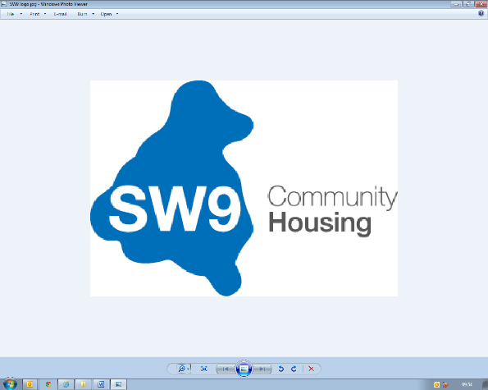 | Role Profile  2025
Job Title: | Complaints Administrator (part- time) 21 hours per week
Reports into: | Customer Resolutions Manager
Responsible for: | N/A
Department/ Location: | Operations/Stockwell
Disclosure Level: | Enhanced/Basic
Candidate Overview | A highly organised and detail-oriented professional with excellent communication and problem-solving skills, the ideal candidate for the Complaints Administrator role is experienced in handling customer complaints with empathy, efficiency, and a strong sense of fairness. They possess a clear understanding of regulatory requirements and organisational policies and are capable of conducting thorough investigations to resolve complaints effectively and within specified timeframes.
Role Purpose: | To support the effective resolution of customer complaints by coordinating communication, tracking progress, and ensuring timely responses in line with organisational policies and service standards. The role focuses on delivering a positive customer experience, maintaining accurate records, and working collaboratively with internal teams to drive continuous improvement and reduce complaint escalation.
Key Responsibilities:
Complaint Management
- Collaborate with the Customer Resolution Manager to ensure timely completion of complaint issues and repairs are completed within the agreed target,
- Implement and maintain a ‘Live’ Action Tracker system to provide real-time visibility and accuracy into the status of all complaints resolutions.
- Engage directly with residents to support the investigation and resolution of complaints, ensuring their concerns are accurately understood and addressed..
- Assist in the resolution of complaints by coordinating efforts across relevant departments and maintaining a customer-focused approach..
- Work proactively to reduce the escalation of complaints by addressing issues promptly and effectively at earliest stage.
- Promote internal accountability by encouraging team members to take ownership of issues raised through complaints.
- Support the Customer Resolution Manager in the compiling ‘Lessons Learned’ from complaints contributing to continuous improvement and sharing insights with the SW9 staffing team.

Customer Service
- Ensure a superior quality customer experience is consistently delivered when supporting the resolution of complaints.
- Work collaboratively with all stakeholders to ensure that the customer is at the centre of all decisions and actions.
- Maintain high levels of customer satisfaction by responding promptly and effectively addressing tenant concerns and feedback.

General
- Inspire and be a role model, consistently demonstrating the SW9 culture and values.
- Attend evening meetings as required.
- Provide assistance to the Head of Customer Services and wider Customer Services Team as reasonably requested.

Passionate about delivering 5* customer service
Standard Responsibilities
Adopt and comply with SW9 values, policies and procedures, and regulatory frameworks including:
- Code of Conduct
- Health and Safety
- Data Protection, privacy, and use of IT resources
- Regulatory standards and probity
- Risks and internal controls framework
- Human Resources policies and procedures
- Equality and diversity
The tasks and responsibilities outlined above are not exhaustive, the post holder may undertake other duties as is required.
Contacts - External/Internal
- Board and Committee members.
- Residents and resident representatives
- Contractors and consultants
- Executive Director, Senior Leadership Team, Operational Managers, and staff within SW9 CH
- SNG Asset Management Team
- Members of Parliament and Local Councillors

Person Specification
Education | - A good standard of education commensurate to the role.
Knowledge | - Excellent customer focus and a genuine desire to achieve excellence in all areas of responsibility.  - Knowledge of social housing sector.
Experience | - Experience managing formal complaints processes within housing, or a similar public-facing environment.  - Advanced experience using NEC/Northgate
Skills | - An enthusiastic individual with a passion for people and customer service  - Someone who is driven and can work on their own initiative and works well as part of a team.  - Excellent administrative skills to manage a diverse workload.  - Confidence using Excel to track, monitor and report on case progression.
Abilities | - A calm and organised approach to handling sensitive or challenging issues.  - Strong verbal communication skills and the ability to adapt this approach for different audiences.  - Ability to work effectively as a member of a small team.  - Excellent listening skills to understand issues raised by a wide variety of customers.  - Ability to use initiative while working within guidelines.  - Excellent time management skills and able to prioritise, plan own workload and show flexibility.  - Adaptable and ‘can do’ attitude.  - A strong focus on service quality and timely resolution.
Systems | - Northgate -NEC  - Use of MS office  - CRM  - SharePoint,  - P2P
Competencies | - Able to manage and prioritise demanding workload.  - Meet deadline and KPIs.  - Calm and professional  - Self-motivated and personal with a ‘can do’ approach.  - Seeks opportunities for improvements.  - Actively demonstrates interest in all aspects of the business
The tasks and responsibilities outlined above are not exhaustive, the post holder may undertake other duties as is required.
We want to make SW9 CH a great place to work and a great organisation that really delivers for its customers. Our HEART behaviours are designed to guide how we work, every day. Everyone within the organisation is expected to demonstrate the four HEART behaviours: -

