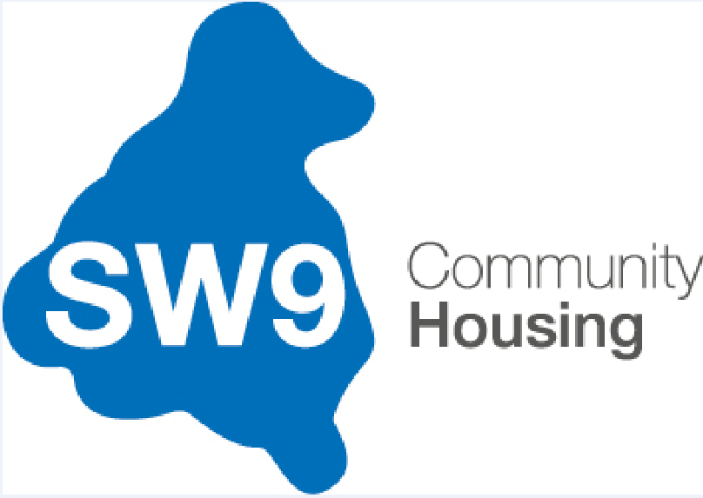 |  | Role Profile  2025
Job Title: |  | Receptionist/Administrative Assistant
Reports into: |  | Senior Neighbourhood Officer
Direct Reports: |  | None
Department / Location: |  | Stockwell
Disclosure Level: |  | None
Candidate Overview |  | We are seeking a friendly, professional, and organised Receptionist / Administrative Assistant to support the day-to-day operations of our housing office. You will be the first point of contact for tenants, contractors, and visitors—both in person and via phone or email—while also providing vital administrative support to the housing and property management teams.  This role requires excellent communication skills, a strong attention to detail, and a commitment to providing high-quality service to our tenants and stakeholders
Role Purpose: |  | The role is a pivotal one within SW9 Community Housing. This is a fantastic opportunity to work as part of our housing management organisation that is rich in history with a thriving, vibrant, and diverse community.  To provide an effective and high-quality reception and administrative support service to the SW9 CH Team.  As Receptionist / Administrative Assistant, you will be responsible for delivering the professional frontline service to SW9 customers behalf of Sovereign Network Group (SNG). You will work as part of the team to deal with customer enquiries by phone or face to face.  This role requires excellent communication skills, a strong attention to detail, and a commitment to providing high-quality service to our tenants and stakeholders.
Main duties and responsibilities:

Reception and Front-of-House Duties
- Greet visitors, tenants, and contractors in a professional and courteous manner, providing a high-quality reception service both in person and over the phone, in line with SW9 CH Reception procedures.
- Manage visitor sign-in procedures and maintain building security protocols.
- Ensure the reception area is clean, tidy, and welcoming at all times.
- Administer parking arrangements, including issuing permits, processing electronic payments, including Direct debits, managing enforcement enquiries, and coordinating with parking contractors.
- Maintain availability of up-to-date leaflets and information on notice boards, the SW9 website, and local service outlets.

Customer Service and Support
- Log all enquiry details into the Customer Hub system to ensure accurate recording of all customer interactions.
- Take ownership of resolving customer queries directly where possible or refer to the appropriate team, providing timely updates and feedback to the customer.
- Provide first-line advice and information to residents and leaseholders on rent, service charges, housing benefits/Universal Credit, and other housing-related matters.
- Support tenants in using the online customer portal by offering basic guidance and promoting self-service.
- Signpost residents and visitors to relevant voluntary, statutory, or internal services as required.

Administrative and Office Support
- Receive, log, distribute, and prepare mail and deliveries in accordance with agreed procedures, including indexing and distributing electronic mail.
- Maintain and update tenant and property records using housing management systems.
- Coordinate meetings, book rooms, and manage diaries for housing staff.
- Prepare letters, notices, meeting minutes, reports, and general correspondence.
- Make appointments for housing officers and other team members as needed.
- Support with administration tasks including:
  - Initial processing of housing applications.
  - Registering council tax and utility bills.
  - Sending rent and service charge statements.
  - Issuing forms and documentation.
- Manage an efficient key and fob control system.

Compliance and Record-Keeping
- Ensure timely and accurate data entry into internal systems, databases, and spreadsheets.
- Maintain confidentiality and handle sensitive tenant and organisational information in line with GDPR and data protection policies.
- Support compliance audits by ensuring that records are up-to-date and meet regulatory standards.

Organisational Values and Culture
- Promote a positive image of SW9 CH by consistently delivering excellent service.
- Act as a role model, demonstrating professionalism and embodying the organisation’s culture and values in all interactions.
- Contribute to ongoing service improvement by maintaining accurate records that help evaluate and enhance the reception function.

Competencies
- Strong Communication Skills
- Organisation Skills
- Customer Service Orientation
- Passionate about delivering 5* customer service
Standard Responsibilities
Adopt and comply with SW9 CH values, policies and procedures, and regulatory frameworks including:

- Code of Conduct
- Health and Safety
- Data Protection, confidentiality, privacy and use of IT resources
- Regulatory standards and probity
- Risks and internal controls framework
- Human Resources policies and procedures
- Equality and diversity

The post holder may be required to undertake duties of a similar nature and at this level elsewhere within the service.
Contacts - External/Internal
- Customers and visitors
- Managers and staff within SW9 CH and across Network Homes
- Contractors
- Other external agencies relevant to role
Person Specification
Education | - A good standard of education to GCSE or equivalent level (including English and Maths).
Knowledge & Skills | - Excellent verbal communication skills sufficient to explain procedures and decisions to a wide range of customers.  - Excellent listening skills sufficient to understand a range of complicated enquiries across a range of different subjects.  - Strong written communication skills in order to accurately record decisions and outcomes in relation to enquiries.  - Excellent customer focus and a genuine desire to resolve issues raised by customers.  - Willingness to learn new areas of work and new approaches to service delivery · Commitment to equality and diversity.  - Proficiency with Microsoft Office Suite (Word, Excel, Outlook).  - Organised and methodical approach · Able to undertake straightforward calculations and record numerical information accurately.  - Excellent attention to detail in all aspects of the work  - Friendly, empathetic, and professional manner—especially when dealing with vulnerable tenants.  - Ability to manage competing priorities and work under pressure  - Ability to use initiative while working within guidelines.  - Excellent time management skills and able to prioritise, plan own workload and show flexibility  - Excellent customer focus and a genuine desire to achieve excellence in all areas of responsibility
Experience | - Experience of working in a busy and varied customer service environment.  - Experience of delivering excellent customer service Experience of working within a team.  - Proven ability to work under pressure, adapt to changes in circumstances, and to be resilient and remain optimistic in the face of adversity.  - Experience of managing conflicting views in a confident, assertive, and diplomatic manner.
Competencies
We want to make SW9 CH a great place to work and a great organisation that really delivers for its customers. Our HART behaviours are designed to guide how we work, every day. Everyone within the organisation is expected to demonstrate the four HART behaviours: -

Hungry – I am ambitious to succeed.
- Optimistic: I am can-do and focussed on what can be done
- Creative: I find new ideas and solutions to challenges
- Bold: I get out my comfort zone and try new things
- Motivated: I welcome feedback and want to succeed

Accountable – I take personal ownership and responsibility to get things done. I make things happen by empowering and delivering through the team and using resources effectively.
- Resilient: I work hard to make things happen
- Disciplined: I am realistic and do what I say I will do
- Personal ownership: I take ownership of an issue until it is resolved
- Confident: I make decisions that are within my remit

Respectful – I treat everyone with respect and understanding. I arrive on time and take full part in meetings.
- Prepared: I arrive on time and take full part in meetings
- Communicator: I listen to others and work hard to communicate well
- Responsive: I always answer a ringing phone and respond quickly
- Self aware: I put myself in others’ shoes and understand how my actions impact on others

Together – I am proud to be one team.
- Positive: I talk positively about SW9 CH as one team
- Proactive: I put myself forward and build great relationships
- Supportive: I support and recognise the contribution of others
- Role model: I genuinely believe I make the difference

