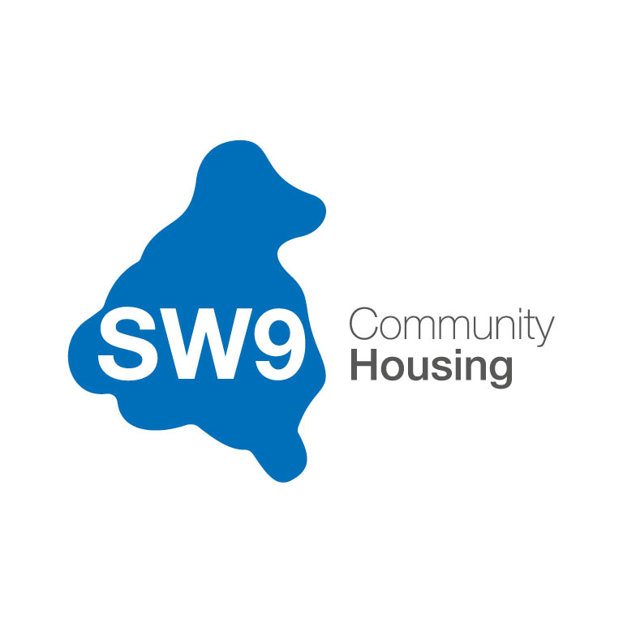

BOARD MEMBER

RECRUITMENT PACK

2022

CONTENTS

Welcome letter from the Executive Director 03
About SW9 04
The Stockwell Story 06
Becoming a Board Member – Frequently Asked Questions 10
SW9 Community Housing Board 2022 14
SW9 Organisation Chart 16
Board Member Role Description 19
Board Member Person Specification 21
Selection Process and Key Dates 25
Application Form 27
Supplementary Documents 32

WELCOME LETTER FROM THE EXECUTIVE DIRECTOR

Dear Applicant,

Thank you for showing an interest in one of the vacant SW9 Community Housing Board Member positions. In this Board Member Recruitment Pack you will find everything you need to know about the organisation, our Board, what we are looking for in a Board member and the application process.
To submit your application, or if you would like to discuss the role and whether it is right for you, please contact:
Telephone: 020 7326 3703
Email: board@sw9.org.uk

The closing date for receipt of applications is midnight on Sunday 14 August 2022.

Yours faithfully,
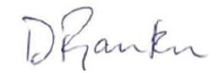
Delroy Rankin
Executive Director

ABOUT SW9 COMMUNITY HOUSING

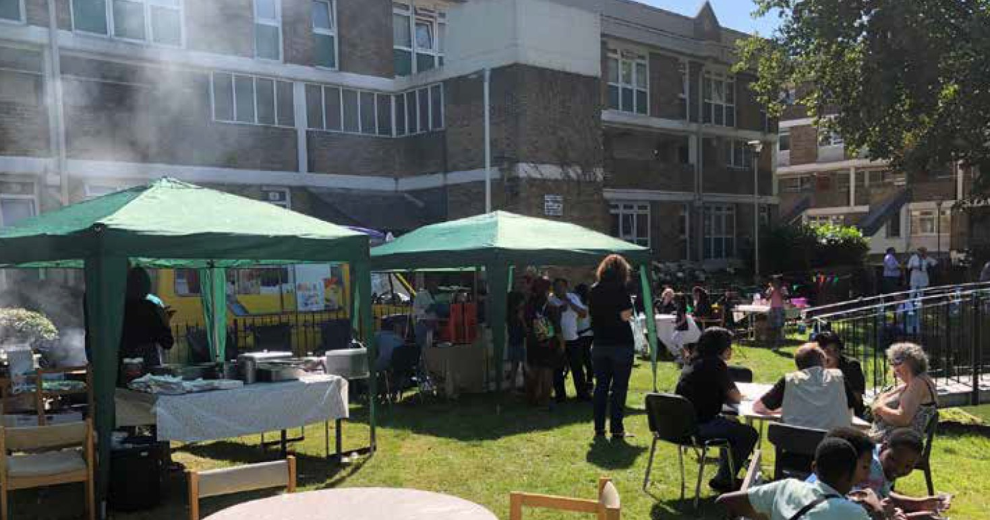
SW9 Community Housing was created in 2016 to work closely with Stockwell’s residents and build a bright future for the estate. As the housing management organisation for Stockwell Park Estate and surrounding street properties, we manage the day-to-day housing services for around 1,500 homes on behalf of the landlord - our parent company, Network Homes.
Our mission is to:
“Work in partnership with local people to provide effective and sustainable housing services, enabling our community to flourish.”

Our values
Our values reflect our commitment to providing excellent services and community cohesion through the empowerment of our residents:
Independence – SW9 aims to operate as an independent socially responsible business that builds on the accomplishments of both CTH and Network Homes.
Local – SW9 wishes to retain its close local links and support local people and businesses.
Quality – SW9 wishes to provide good quality housing and services which will not only benefit residents but also enhance their quality of life. We will also demonstrate, deliver and promote recognised good practice within the tenant-led housing sector.
Working in partnership – SW9 is keen to work in partnership with the local authority, other housing providers and organisations whenever this will benefit the provision of local housing and services.
Value for money – SW9 aims to ensure it delivers competitive, high quality services that represent value for money for our residents.
Financially sound – SW9 will be prudent in its financial management. This will ensure a strong and viable future with the ability to continue to maintain existing homes and offer a full range of services to a high standard.
Integrity – The Board and staff will operate in an environment which supports the highest levels of integrity: where openness is encouraged across all our activities and with our stakeholders and partners. Our governance will be regularly reviewed to ensure appropriate controls and accountability across all areas of our business.

SW9 Community Housing in numbers
The total number of properties we manage is 1718. This is made up of:
904  General Needs | 642  Leasehold | 57  Shared Ownership
48  Supported Housing | 40  Active Elderly | 27  Short Term Lets

THE STOCKWELL STORY
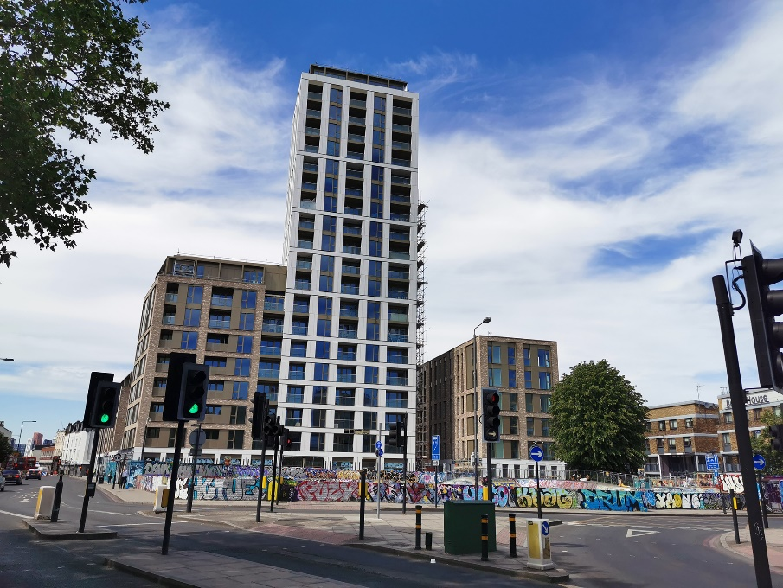
Homes and the people who live in them are important to us. They’re the reason we do what we do.
There’s a strong sense of community and a tradition of resident involvement in the way that housing on the Stockwell Park Estate is managed. We believe it is this tradition and heritage that makes the area so special. This sense of community has grown over a story stretching back more than 25 years.
Although Stockwell Park had originally been created as an example for modern living and vibrant communities (winning several awards for its multi-level design in the 1960s), some thirty years later it was considered a failing estate. Ranked as one of the worst places for crime, anti-social behaviour (ASB) and deprivation both within London and nationally, it had also become closely associated with the Brixton Riots of the 1980s.
With some irony perhaps, many of the problems identified were seen to be a direct result of the design which had been applauded during the 1960s. The multi-level access design feature had led to ASB moving from the streets to the podium level where it was difficult to police. As a result, many services were unwilling to fully engage in the area, including the postal service.
In 1995, a group of residents led by Julie Fawcett, lobbied Lambeth Council for action to be taken for the Estate. They formed the Stockwell Park Community Trust – a Tenant Management Organisation (TMO) – allowing them to take advantage of the Estate Action Funding programme. This would see the bill for much-needed investment shared equally between the local authority and central government.
A year later, the regeneration of the estate kicked off in earnest with Fitzgerald House being the first to undergo refurbishment. This largely centred on moving front door access to ground level, to create a greater ‘overlooking’ of the estate. Between 1997 and 2001, improvements carried on apace with large scale refurbishments at Burrow House, Turberville House, Crowhurst House, Chute House and the Community Centre. However, with only the inner core of the estate completed, Estate Action Funding was brought to an end meaning work would have to cease unless alternative funding could be found.
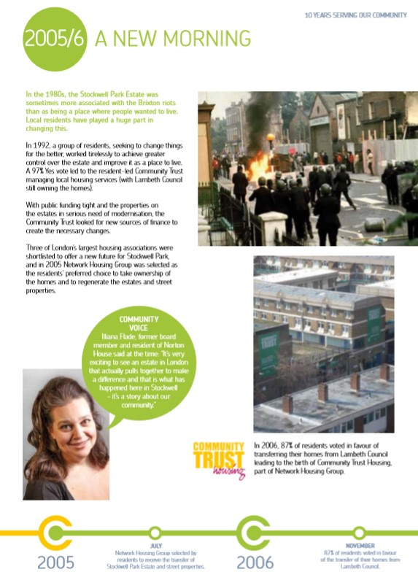
The Stockwell Park Community Trust now looked to the increasingly popular stock transfer model (which was being used around the country) to unlock this potential. Between 2002-3 a stock option proposal was created including a feasibility study. The advice from this was to become more adventurous; to also create new homes as well as refurbish the existing stock (which was simultaneously being brought up to the government’s 2010 Decent Homes Standard through bids to central government).

Although a range of partners were explored, including many of London’s G15 Housing Associations, the Trust wanted to maintain as much independence as possible rather than become amalgamated into a wider group. The decision was therefore made to partner with Network Housing Group, which operated on a more federal structure incorporating a variety of different housing providers each with their own Board and aspirations.
In 2005 a ballot of residents was held with a staggering 79.9% voting in favour of transfer. This was largely down to the hard work of the TMO staff and volunteers who took pride in their mission, door knocking and holding events to promote the potential good the partnership could do for the local area and residents.
On 31 March 2007, the newly renamed Community Trust Housing (CTH) began operating as a part of the Network Housing Group, with Denchworth House being the first beneficiary of regeneration. The new relationship continued to thrive despite the impact of the wider national environment, including the financial crash of 2008.
Promises were kept by switching a number of properties intended for outright sale to general rent, leading to greater than planned mixed communities when Lidcote and Cumnor were completed.
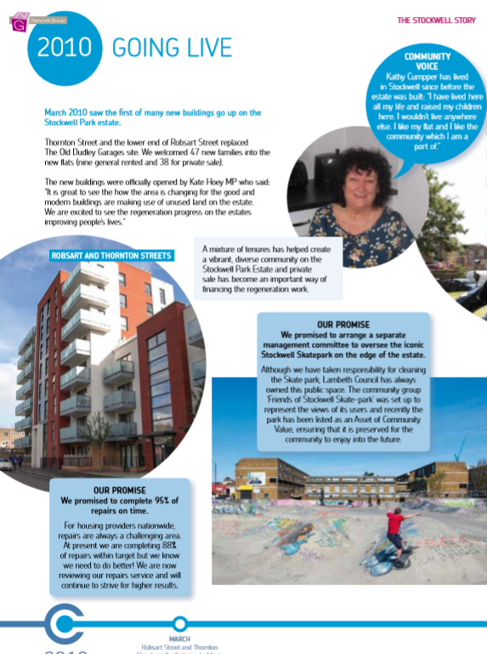
This period also saw the completion of the first new build properties with 57 homes developed on the site of the old Dudley Garages, now renamed 19 Robsart Street. The successful completion of these projects was a matter of great pride, as they were managed internally with no support available from Lambeth Council in the necessary decant work. This success directly led to the decision to demolish Weyland House (which had been due simply for refurbishment) so that the award winning Park Heights could be constructed.

Again, times were changing and, when a change of focus at Network Housing Group led to plans to collapse the group structure, CTH worked to maintain its independent nature. A two-year negotiation led to an arrangement whereby Network Housing Group could become one organisation, but CTH could also remain in a manner that respected its local character.
With a Management Agreement in place, SW9 Community Housing began operation in March 2016. A new organisation with its own resident-led Board and purpose-built offices, the arrangement allowed SW9 to retain 53% of rental agreement over a period of 25 years with an option to seek independence after 5 years.
As the housing management organisation for the Stockwell Park Estate and surrounding street properties, SW9 Community Housing works closely with its residents to build a bright future for the estate while managing the day-to-day housing services for around 1,600 homes on behalf of the landlord – its parent company, Network Homes. It is part of a tradition that we are proud to continue.
The current decision which affects the Stockwell Park Estate and surrounding street properties is just as important (if not more) than some of the momentous events navigated by previous board members in predecessor organisations. It is to decide whether the future ownership of the Estate should remain in the hands of the ‘corporate entity’ that is Network Homes, or whether present and future residents of the Estate would be better served by having ownership more closely aligned with the management and services provided to the Estate and its residents, by a locally focussed organisation that is SW9. This is a complicated and complex decision for which a ballot of residents is necessary.
In representing the arguments ‘for’ and ‘against’ independence, many residents will have due regard for the Estate’s history and the progress made thus far. But in reality, how much should historic events of the past influence plans for the future, indeed, should they have any bearing at all? These are the type of questions which will need careful consideration now, to arrive at clear strategic answers to some of the questions which will inevitably be posed by residents.
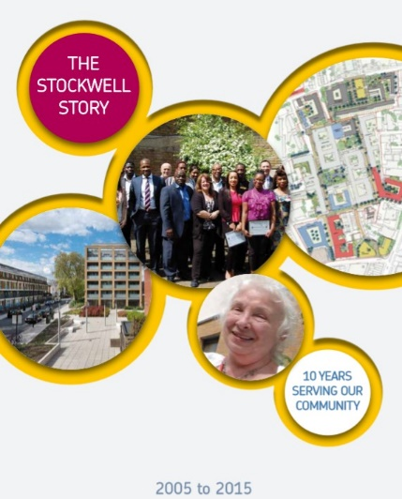
This document has been adapted from ‘The Stockwell Story’ originally published by Community trust Housing in 2015.
If you would like a copy of the original, please contact communications@sw9.org.uk

BECOMING A BOARD MEMBER – FREQUENTLY ASKED QUESTIONS

- How are SW9 Community Housing Board members chosen?

If you’re interested in becoming an SW9 Community Housing Board member then you’ll go through a recruitment and selection process. This is to make sure you know what is involved while also giving us an opportunity to check that you’ve got the right skills and are able to put in the necessary time and commitment.
First you will need to fill out the application form. This will give you the chance to tell us about yourself, your skills, knowledge and experience. We will then review the applications we receive and draw up a shortlist. If you are on the shortlist, we will ask you to come and see us for an interview.

If we have more suitable applicants than vacancies to become SW9 Community Housing Board members, the process may then move on to a second stage, which could include an election.

- What if I’m not chosen to become an SW9 Community Housing Board member? Will I have wasted my time?

Absolutely not! If you don’t manage to become an SW9 Community Housing Board member on this occasion, then you will get another chance to try again next time.

In the meantime, Komal Doan, Community Engagement and Communications Manager, can talk to you about other activities that may be of interest and will certainly help you gain more knowledge for the next time you put in an application.

- How much time will I have to commit to being an SW9 Community Housing Board member?

It is difficult to be exact as the time involved will depend on what needs to be discussed. As a general guide there are likely to be:
- 6 x 2 hour meetings per year (usually on the last Tuesday evening of each month).
- About three hour’s preparation in your own time before each meeting to read notes and reports.
- Personalised training programmes.
- A few occasions where you represent the organisation at external meetings or open events.
- Attendance at one or two “away days” per year.

In addition, you may be required to sit on two committees which meet approximately four times a year. The extra time commitment for this varies by committee and will be discussed with you beforehand.

- What is a Board? What does it do?

A Board is a group of elected or appointed individuals who jointly oversee the activities of a company or organisation.

The SW9 Community Housing Board will set our strategic direction and is accountable to our residents and other stakeholders for our overall performance in delivering housing services to our residents.

If you are on the SW9 Community Housing Board, you will also have responsibility for:
- The overall management of the organisation.
- The approval of the annual business plan.
- The approval of our annual report and financial statement (this is also subject to external audit).
- Deciding which areas of responsibility are to be delegated to committees or our staff.

However, the day to day running of the organisation is delegated to our management team.

- What would make a great SW9 Community Housing Board member?

We are looking for certain key values in an SW9 Community Housing Board member. We want them to help us achieve homes and neighbourhoods we can all be proud of and support the values that underpin our daily activities. We expect them to further the wellbeing of our organisation, residents and the wider community in which we operate. We also need them to execute their role responsibly and ensure confidentiality is maintained.

We want SW9 Community Housing Board members to make decisions that allow us to make a difference.

- What skills do SW9 Community Housing Board members need?

The following would make a great start!
- Team working – you must be able to work positively as a member of a diverse team. You will face sensitive / challenging issues and will need to accept differing views, being ready to compromise if required.
- Self-management – you need to be enthusiastic and committed to all your responsibilities.
- Decision making – you must have the ability to weigh up issues and make balanced and reasonable judgements and decisions.
- Analysis and challenging – you need to have the skills to analyse, question and constructively challenge issues.
- Communication – you will be an effective communicator with tenants, leaseholders, our staff and other members.

- What would I get out of being an SW9 Community Housing Board member?

Being an SW9 Community Housing Board member would mean making a difference in the area you live. You will be enhancing the lives of your neighbours by taking decisions that will improve homes, communities and individual lives.

Here’s an idea of what you’ll get back by becoming an SW9 Community Housing Board member:

- Gaining experience – being part of the SW9 Community Housing Board will give you some really useful experience and skills that are easily transferable to other situations. Our current and past members tell us that the skills and knowledge they built up have helped their personal development and were a very useful addition to their CVs.
- Getting you thinking – our members have to make some difficult decisions. You will be analysing, reviewing and debating on a regular basis. This might sound overwhelming, but with the support of our member training, you’ll be ready to take on even the biggest challenge.
- Acquiring skills – we know that for some, becoming a Board member can be a new experience. So for all our new members we run an induction session and then, according to your particular needs, we put together an annual training programme so that you’re fully prepared.
- Being effective – You will make a lot of important decisions that will positively impact on the lives of residents and shape the neighbourhood in which they live.
- Achieving change – there’s often a great sense of satisfaction and fulfilment in the knowledge that you will be achieving positive change by being part of an effective and responsible Board.
- Covering costs – although being a member is a voluntary role, we will cover any relevant out of pocket expenses. That might include training or transport costs, the cost of childcare or other caring responsibilities.

Becoming an SW9 Community Housing Board member is a varied and challenging role. You’ll need to have time, commitment and enthusiasm. If this sounds like you, then please get in touch. For more information contact?

Telephone: 020 7326 3703
Email: Board@sw9.org.uk

SW9 COMMUNITY HOUSING CURRENT BOARD MEMBERS

Dee Alapafuja  Chair and Tenant Board Member  Dee has lived on both the estate and in a street property for 20 years. Working in various roles at Transport for London, he has developed a passion for customer service. | Olu Ajisebutu  Vice-Chair and Leasehold Board Member  Olu first became involved in CTH when the Community Trust was carrying out pre-transfer consultation. He joined a resident’s forum who met throughout 2005/6 to evaluate the feasibility of transfer. | Daniel Cromb  Leasehold Board Member  Daniel is a leaseholder who grew up in south London. He is a doctor and a passionate advocate for community involvement and equality.
Paul Brett  Leasehold Board Member  A newcomer to the area, self-employed consultant Paul is keen to get involved with the community. He wants to help “modernise systems which provide services and increase resident satisfaction.” | Daniel Garza  Tenant Board Member  Daniel has lived on the estate for five years and is a self-employed engineer. He is keen to contribute to developing a “safe, better and evolving community”. | Steven Warren  Tenant Board Member  A tenant of Stockwell Park Estate, Steven is a Private Consultant, delivering counselling and psychotherapy. He was previously the Chairman of an international advanced medical treatment company.

Adebayo Ajibade  Tenant Board Member  Adebayo has lived on Stockwell Park Estate for over 8 years. He is an Accounting Officer with over 5 years’ experience in Accounting and Management. | Colin Faulkner  Independent Board Member  Colin currently works as Director of Government at UK Green Investment Bank. He has previously been a trustee for Wester Hailes, a charity focusing on community regeneration through the arts. | Andrew Sternberg  Independent Board Member  Andrew has over 30 years’ experience working in the public and social housing sectors. He currently works for the Foreign Commonwealth and Development Office as a Commercial Delivery Manager supporting overseas development programmes.
Kieran Godwin  Independent Board Member | Tazeem Abbas  Independent Board Member | Cllr Joshua Lindsey  Lambeth Council Representative  Lambeth Councillor for the Ferndale Ward, Joshua is also a former resident of Stockwell Park. He has a keen interest in housing and has campaigned for more affordable homes.

SW9 ORGANISATION CHART

Senior Leadership Team
Delroy Rankin  Executive Director  Delroy starting working at Stockwell Park in October 1998. He held a number of housing management positions before being appointed Executive Director in 2006. Delroy was part of the team that oversaw the Stock Transfer and assisted in developing the regeneration proposals that have transformed the estate over the last 13 years.  An ardent supporter of social housing, Delroy headed the transition of Community Trust Housing to SW9 Community Housing in 2016, ensuring the longstanding tradition of resident-led housing at Stockwell was preserved. | Felicity Dunmall  Head of Housing and Estate Services  Joined SW9 in July 2022.
Orane Lewis  Head of Finance and Resources  Orane is a fellow member of the Association of the Chartered Certified Accountants (ACCA) and a member of the Association of Accounting Technicians (AAT). He joined SW9 as Head of Finance in February 2020 and brings over 20 years’ experience in social housing and charity finance, where he held several managerial roles. Orane has responsibility of the Finance, Service charges and the HR function at SW9. | Dipak Patel  Head of Corporate Services  Dipak joined SW9 in March 2020 and brings over 20 years’ experience in the housing and health care sectors, including director level roles in Corporate Services and Finance. He joined SW9 at a pivotal time as it explores alternatives for the ownership and management of the Estate.

Corporate Services Team  Jessica Johnson  Executive Assistant and Office Manager  Lauren Stocks  Graduate Policy and Performance Officer  Zoe Christodoulou  Policy and Performance Officer  Benjamin Robinson  Business Support Officer | Finance and Human Resources Team  Krishanthan Senthivel  Finance Manager  Melita Da Silva  Finance Officer  Belief Otite  Service Charge Accountant  Alaha Nourzai  HR Adviser  Andrea Lewis  HR Manager
Leasehold Services  Gabriel Aboyeji  Leasehold Property Manager  Gloria Nelson  Leasehold Services Officer | Income Team  Lan Chuong  Interim Income Team Leader
Housing Services  Patricia Aihie  Housing Services Manager  Olu Adedotun  Neighbourhood Services Officer  Jessica Cinik  Neighbourhood Services Officer  Novelette Ellis  Tenancy Support Officer  Lana Hunte  Supported Housing Scheme Manager  Elizabeth Tedla  Housekeeper  Cassima Hanson  Housing Assistant  Sonia Hinds  Receptionist and Admin Assistant | Property Services  Ray Hussain  Repairs and Maintenance Manager  Aemiro Kassa  Property Services Officer  Georgia Roachford  Customer Services Assistant  Veronica Sanchez Aguirre  Customer Services Assistant  Musa Ndengu  Temporary Technical Surveyor  Glenn Franks  Senior Technical Surveyor

Community & Communications  Komal Doan  Community Engagement and  Communications Manager  Denise Bailey  Communications Executive  Kelly Tran  Communications Assistant | SW9 Cleaning  Veronica Mendoza Villa  Fnot Bekretsyen  Alganesh Habte  Juan Rojas Florez  Walter Masaquiza Diaz  Catherine Egbine  Hidat Weldegiorges  Ricardo Candelo Moran  Alem Kahsay  Diego Guzman  Jose Da Costa Gomes  Yordanos Birhane  Peter Howley  Avelino Silva Rodrigues
Estate Services

Michelle Levy
Estates Manager
Davison Hunte
Estate Services Officer
Andrew Woodman
Estate Services Officer

BOARD MEMBER ROLE DESCRIPTION

Purpose

To take ultimate responsibility, with fellow Board members, for providing leadership and directing the affairs of SW9 Community Housing, ensuring that it is solvent, well-run and delivering the outcomes for the benefit of the local community, stakeholders and other beneficiaries identified in the Business Plan.

Main responsibilities

The principal responsibility of a Board member is to bring your perspective (as a tenant, leaseholder or independent) to the following responsibilities of all Board members:

Legal
- To ensure that SW9 Community Housing complies with all legal requirements – under company and charity law – particularly to prepare an Annual Return, Annual Report and Accounts. Plus, to comply with any other legal or regulatory requirements.
- To ensure that SW9 Community Housing pursues its charitable objectives, whilst providing a publicly beneficial outcome.
- To ensure that SW9 Community Housing uses its resources effectively, efficiently and exclusively in pursuance of its objectives.
- To uphold the fiduciary duty invested in the position, undertaking such duties in a way that adds to public confidence in SW9 Community Housing.
- To act at all times in the best interests of SW9 Community Housing, its beneficiaries and future beneficiaries.
- To ensure compliance with the terms of the Rental Sale Agreement at all times.

Strategic
- To contribute actively to the Board's role in determining SW9 Community Housing’s strategic direction. This entails setting an overall policy, defining goals and objectives, evaluating opportunities, evaluating risks, and monitoring performance against agreed targets.
- To keep under review the ongoing development of SW9 Community Housing in light of the political, economic and social environment within which it operates.
- To safeguard SW9’s reputation and to uphold its values and principles.

Financial and risk
- To ensure SW9 Community Housing’s financial stability and viability.
- To ensure a framework of prudent and effective controls is in place which enable risk to be identified, assessed and managed.

Services
- To ensure that SW9 Community Housing delivers excellent customer services which, as a minimum, meet all the requirements set out in the Rental Sale Agreement.

Other
- To appoint and, where necessary, dismiss the Executive Director.
- To ensure the effective and efficient administration of SW9 Community Housing and to strive for governance best practice.
- To take appropriate professional advice on matters where there may be material risk to SW9 Community Housing.
- To uphold and promote the mission, vision and values of SW9 Community Housing and its commitment to equal opportunities and diversity.
- To attend induction and training programmes.
- To maintain the confidentiality of all sensitive / confidential information received in the course of a Board member’s responsibilities.
- To use professional and personal skills, networks, and local knowledge to assist SW9 Community Housing to develop as a well-run business, achieving its aims.
- To act with integrity and avoid any personal conflicts of interest or misuse of charity funds or assets and to comply with the SW9 Community Housing Board Member Code of Conduct.
- To undertake such duties as may reasonably be required, including participating in meetings, other events and activities.

BOARD MEMBER PERSON SPECIFICATION
A recent skills audit of existing Board Members showed the following strengths / weaknesses in the collective skill sets / competencies:
Business Area | Skill/competancy | Total
Finance and Investment | Financial planning and Stress Testing | 20
Housing Property and Development | Regulation and inspection for social housing (or a similar regulated area) | 24
Finance and Investment | Treasury management | 24
Housing Property and Development | Property Procurement and Contracting | 24
Housing Property and Development | Property and asset management, maintenance and investment | 25
Finance and Investment | Accounting and internal audit | 25
Housing Property and Development | Funding, planning and development for housing and regeneration | 27
Housing Property and Development | Sustainability in terms of reducing energy use, pollution, carbon impact | 28
Finance and Investment | Business Planning & Scenario Testing | 28
Finance and Investment | Financial Viability | 28
Regulation and Governance | Regulatory Requirements | 28
Housing Property and Development | Repairs and Maintenance of Social Housing | 28
Strategy and Policy Development | Sector Policy | 29
Housing Property and Development | Development Strategy and delivery | 29
Regulation and Governance | Information technology and business systems | 29
Regulation and Governance | Procurement | 29
Regulation and Governance | Human Resources | 30
Tenants/Residents, Community, Customer Service & Neighbourhood Issues | Economic development, financial inclusion and employment creation initiatives | 30
Tenants/Residents, Community, Customer Service & Neighbourhood Issues | Community cohesion | 31
Regulation and Governance | Data Protection | 31
Regulation and Governance | Health and Safety | 31
Housing Property and Development | Working with local authorities, health authorities and other bodies | 31
Strategy and Policy Development | Delivering change | 32
Tenants/Residents, Community, Customer Service & Neighbourhood Issues | Regeneration | 32
Regulation and Governance | Knowledge of statutory authorities, including their role and how they operate | 32
Finance and Investment | Delivering value for Money | 32
Regulation and Governance | Organisational Performance | 32
Finance and Investment | Risk Management | 32
Regulation and Governance | Constructive Challenge | 33
Strategy and Policy Development | Business Development | 34
Regulation and Governance | Equality and Diversity | 34
Strategy and Policy Development | Communications | 34
Strategy and Policy Development | Leadership and Strategy | 35
Tenants/Residents, Community, Customer Service & Neighbourhood Issues | Tenants/residents engagement | 35
Tenants/Residents, Community, Customer Service & Neighbourhood Issues | Good customer service and performance management | 36
Tenants/Residents, Community, Customer Service & Neighbourhood Issues | Knowledge of the local community and aspirations of the diverse residents and communities we serve | 37
Regulation and Governance | Good Governance | 38

Based on this, we would particularly welcome women applicants with the following key attributes which SW9 is currently looking for in new Board Members:
- Experience in finance (preferably Social Housing Finance).
- Experience in social housing management.
In addition, the following core attributes are essential:

Abilities and Skills
- An ability to perform the individual core functions of a Board Member:
- Able to read and absorb information on the full range of SW9’s business areas.
- Ability to probe facts, challenge assumptions and identify the advantages and disadvantages of proposals.
- Ability to work at a strategic level, think creatively and criticise constructively.
- Good, independent judgement and a willingness to speak your mind.

- To be able to work as a team member:
- Develop and maintain constructive working relationships with colleagues.

- Understanding of (and commitment to) supporting diversity:
- Understand equal opportunities principles.
- Support for maintaining and developing a diverse community.

- To be able to exercise financial control:
- Evaluate and review financial information – in particular, budgets.

Motivation
The role requires a commitment to what the organisation is trying to achieve. Therefore, setting aside sufficient time is needed in order perform the role effectively. That includes:

- Commitment to providing excellent customer services.
- Commitment to SW9 Community Housing’s vision of a diverse, strong and sustainable community.
- Commitment to attend the majority of Board and other meetings – personal circumstances must allow for this.
- Commitment to read all papers and allow enough time for preparation prior to meetings.
- Willingness to work outside of the meetings with the Executive Director and Board in areas of expertise and to provide access to networks (Independent members particularly).
- Commitment to receive appropriate training as an individual and as part of the Board team.
- Commitment to open, inclusive and transparent methods of working.

Knowledge & Experience
Candidates should have knowledge and/or experience, either professional or personal of at least two of the following:

- The SW9 community.
- Repairs & maintenance.
- Customer services.
- Social housing.
- Housing development.
- Tenant/Leaseholder Issues.
- Finance.
- Staff management and recruitment.
- Performance management.
- Contract management.
- Communications – especially digital.
- Community development.
- TMO management.
- Governance.
- Previous experience of serving on a Board or Committee.

For more information please contact:

Telephone: 020 7326 3703
Email: Boardl@sw9.org.uk

SELECTION PROCESS AND KEY DATES

The SW9 Community Housing Board is currently looking for a limited number of Board Members to fill vacant positions. Board member positions fall into three categories:
- Tenant Board member.
- Leaseholder Board member.
- Independent Board member.

The positions that currently need filling are:
- Tenant Board member.
- Leaseholder Board member.

Potential applicants for the positions should complete an Application Form and submit it to SW9 using the details below by the closing date of midnight on Sunday 14 August 2022.
All qualifying applicants who apply will be interviewed by a Selection Panel. The Selection Panel members will consist of two current SW9 Board Members and Delroy Rankin (SW9 Community Housing Executive Director). The Selection Panel will assess each applicant’s ability to fulfil the role of a Board member as measured against the Person Specification.
If there are more candidates than vacancies following selection, then a second stage will be held.

To submit your application, or if you would like to discuss the role and whether it is right for you, please contact:
Telephone: 020 7326 3700
Email: Board@sw9.org.uk

Date | Stage
Sunday 14 August (midnight) | This is when you must return your completed application form. This can be done:  - Physically to the SW9 Community Housing office at 6 Stockwell Park Walk, London, SW9 0FG.  - Via email to Board@sw9.org.uk

APPLICATION FORM

Important Notes
- All tenant and leaseholder applicants must be a resident of SW9 Community Housing at the date of their application.
- Board members will not receive financial or similar benefits from their position.
- Board members are directors of the company and will be legally responsible for the management and supervision of the organisation.
- Candidates must fill out all sections of this application.
- All successful candidates must be prepared to undertake appropriate training if required.
- All successful candidates will be required to sign the terms of appointment issued by SW9 Community Housing.

About you
Title

First name

Surname

Date of birth

Address

Postcode

Telephone

Email

How long have you been a resident? (if applicable)

Your experience
Please include the most up to date version of your CV with this application.
If you do not have an up-to-date CV, please use this space tell us about any professional, voluntary or personal experience that you feel may support your application to become a Board member. Please continue on a separate piece of paper if necessary.

Your qualifications
Please list any qualifications you hold.
Qualification | Level | Institution | Date

Your expertise
Please let us know how knowledgeable you feel you are in the following areas. Please note we do not expect you to be an expert in all these areas.

1: No knowledge. 5: Very knowledgeable
Housing issues
Social housing and related policy issues | 1 | 2 | 3 | 4 | 5
Management housing | 1 | 2 | 3 | 4 | 5
Housing law | 1 | 2 | 3 | 4 | 5
Housing, construction, maintenance and repairs | 1 | 2 | 3 | 4 | 5
Business
Business strategy | 1 | 2 | 3 | 4 | 5
Business planning and business management | 1 | 2 | 3 | 4 | 5
Financial planning | 1 | 2 | 3 | 4 | 5
Organisational development and HR management | 1 | 2 | 3 | 4 | 5
Information technology | 1 | 2 | 3 | 4 | 5
Procurement | 1 | 2 | 3 | 4 | 5
Community development and resident engagement
Community development | 1 | 2 | 3 | 4 | 5
Resident engagement | 1 | 2 | 3 | 4 | 5

Personal statement

- In no more than 100 words please explain why you would like to be a Board member of SW9 Community Housing.

- In no more than 100 words please tell us the key skills and experience you will bring as a Board member.

- In the case of Tenant / Leaseholder Board members, it is possible that an election may be necessary. In no more than 20 words, tell voters why they should vote for you.

Candidate declaration
There are certain people who may not be eligible to become a Board member. Please read these notes fully before signing this declaration.
You will not be eligible to be a Board Member if:
- You are less than 18 years of age.
- You are disqualified from being a company director.
- You are currently declared bankrupt (or are subject to bankruptcy restrictions or an interim order).
- You have entered into an individual voluntary agreement to pay off debts with creditors.
- You have an unspent conviction for an offence involving dishonesty or deception.
- You have previously been removed from a charity trustee due to misconduct or mismanagement.
- You are disqualified or barred from acting as a trustee under the Safeguarding Vulnerable Groups Act 2006.

The information you give us will be used for the following purposes:
- To enable SW9 Community Housing to keep a record of your application.
- To enable SW9 Community Housing to compile statistics (provided that no statistical information that would identify you as an individual will be published).

The information provided will be kept securely, and no longer than necessary.
For more information on how we use your data, please visit:
www.sw9.org.uk/privacy-statement

I declare that the information on this form is correct. If appointed I understand I will be liable to action that could lead to removal from the Board if I knowingly give false information.
Signature

Date

SUPPLEMENTARY DOCUMENTS

SW9 Board Member Code of Conduct – Available on request or to download.
SW9 Corporate Plan – Available on request or to download.
SW9 Articles of Association – Available on request or to download.
SW9 Confidentiality Policy – Available on request or to download.
SW9 Equality and Diversity Policy – Available on request or to download.
SW9 Health and Safety Policy – Available on request or to download.
SW9 Performance Scorecard 2021-22 – Available on request
SW9 ‘Our Community News’ (latest issue) – Available on request or to download.
SW9 Annual Report 2021-22 – Available on request or to download.

